

Capstone Project Report

On

“**Travel App**”

<https://github.com/deepanksingh1122/Capstone-Travel-Approval-App.git>

Submitted by:

**Name:** DEEPANK SINGH

**Batch** WIP-SF-13

**LMS Id:**  MGSA_508

**Date:** 18/10/1999

**Table of contents**

1. Abstract………………………………………………

2. Introduction…………………………………………...

3. Flow of the project……………………………………

4. Software Requirements……………………………….

5. Screen shots………………………………………….

Module1……………………………………………..

Module2……………………………………………..

Module3……………………………………………..

6.Future enhancements………………………………….

7. References…………………………………………….

**Abstract**

Our organization has decided to implement a custom travel approval app. Up until now, we had a travel approval process in place based on emailing spreadsheets. It had no central repository or enforcement of the process, resulting in the inability to report on travel approval activities across the organization. You need to create an application that meets these requirements:

* Each employee must submit an electronic request in the system for future travel.
* Each request includes a list of estimated expenses for airfare, hotel, rental car, and so on.
* Each request must be approved by the employee’s manager, and all out-of-state travel must be approved by a travel coordinator.
* Managers need reports and dashboards to track key travel request trends and KPIs.
* In addition, employees and managers must be able to access their travel requests, approvals, and dashboards via mobile device.

By the end of the project, we’ll have a working prototype of the new travel approval application. We start by creating a travel approval app that provides a view of your specific travel-related objects

.

**Introduction**

Salesforce is a cloud-based software company that provides its customers with a platform to develop their own applications without following the tough steps that they used to follow in the legacy system. The software or application once created can be uploaded onto the cloud allowing the end-users to view them.

Salesforce is currently providing various software solutions and platforms for developers to create and distribute custom software/applications. Tech giants like Google, Twitter, Amazon, and Facebook are using Salesforce either in the form of SaaS or PaaS.



*Salesforce developers can make an application on the cloud and share it with multiple companies across multiple domains by using Salesforce.*

Talking about HR systems, every company across the globe has an HR team. Each HR team would require an HR application to store employee records. Almost all specifications for such an application would be common for all companies. So, as a developer, it would be very easy to create a Salesforce application for such specifications, post it onto the cloud, and provide it as a service to multiple clients at the same time. Maintenance of the same can be done altogether too. So basically, the problem of scalability gets eliminated.

**Flow of the Project**

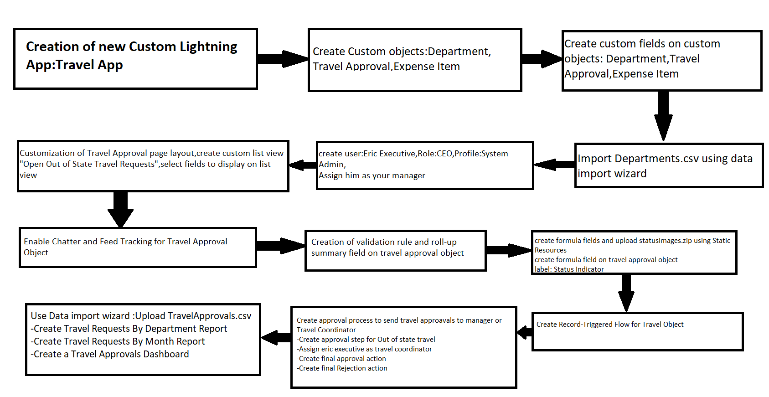

**Software Requirements**

For the fastest and most stable experience, we recommend:

* An Octane 2.0 score of 30,000 or greater
* Network latency of 150 ms or less
* Download speed of 3 Mbps or greater
* At least 8 GB of RAM, with 3 GB available for Salesforce browser tabs

Minimum requirements are:

* An Octane 2.0 score of 20,000 or greater
* Network latency of 200 ms or less
* Download speed of 1 Mbps or greater
* At least 5 GB of RAM, with 2 GB available for Salesforce browser tabs

**OR**

|  |  |
| --- | --- |
| **Requirements** | |
| **Windows** | | |
| **Operating system** | [Windows 8.1](https://en.wikipedia.org/wiki/Windows_8.1) 64-bit, [Windows 8](https://en.wikipedia.org/wiki/Windows_8) 64-bit, Windows 7 Service Pack 1 64-bit, Windows Vista Service Pack 2 64-bit | |
| **CPU** | [Core 2 Quad](https://en.wikipedia.org/wiki/Core_2_Quad) Q6600 at 2.4 GHz or [AMD Phenom](https://en.wikipedia.org/wiki/AMD_Phenom) 9850 at 2.5 GHz | |
| **Memory** | 4 GB [RAM](https://en.wikipedia.org/wiki/Random_Access_Memory) | |
| **Free space** | 65 GB of free space | |
| **Graphics hardware** | DirectX 10-compatible [GPU](https://en.wikipedia.org/wiki/GPU): [GeForce 9800GT](https://en.wikipedia.org/wiki/GeForce_9_series) 1GB or [ATI Radeon HD 4870](https://en.wikipedia.org/wiki/Radeon_HD_4000_series#Radeon_HD_4800) 1GB | |
| **Sound hardware** | [DirectX](https://en.wikipedia.org/wiki/DirectX) 10 compatible [sound card](https://en.wikipedia.org/wiki/Sound_card) | |

**Screenshots**

**Module1.exercise1**

Step1:Creation of Travel app

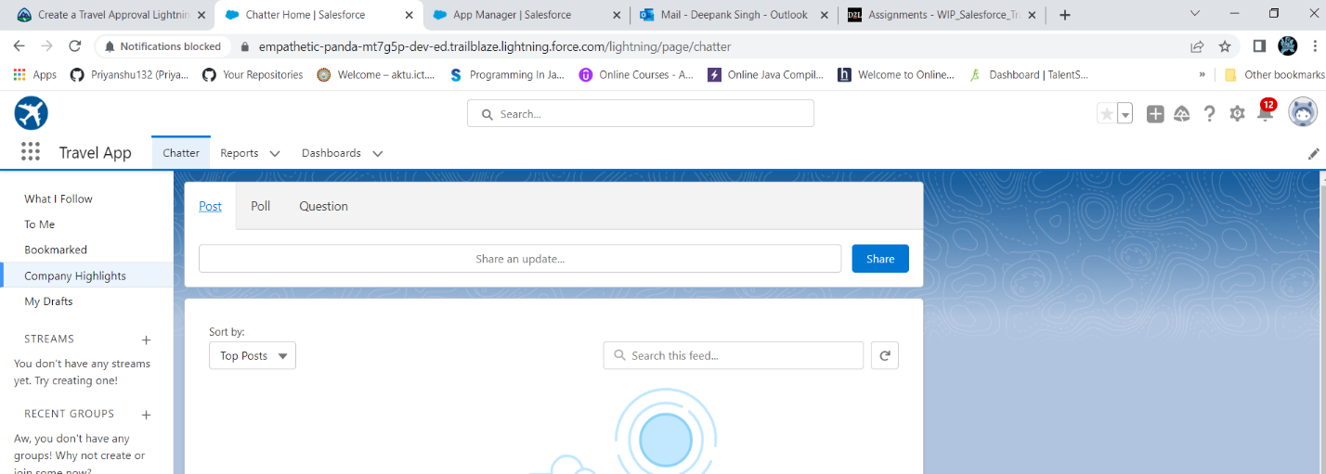

Step2:Creation of Department custom object

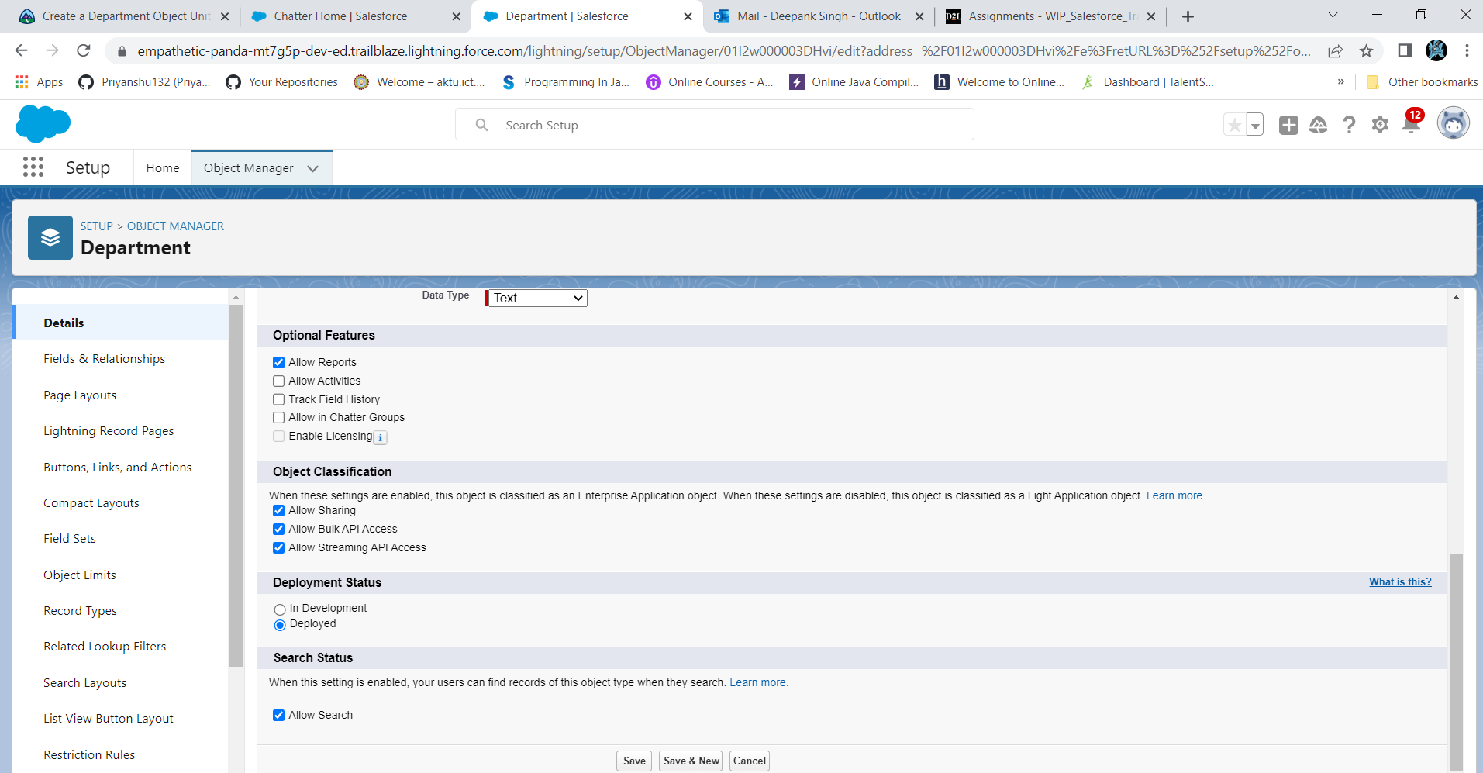

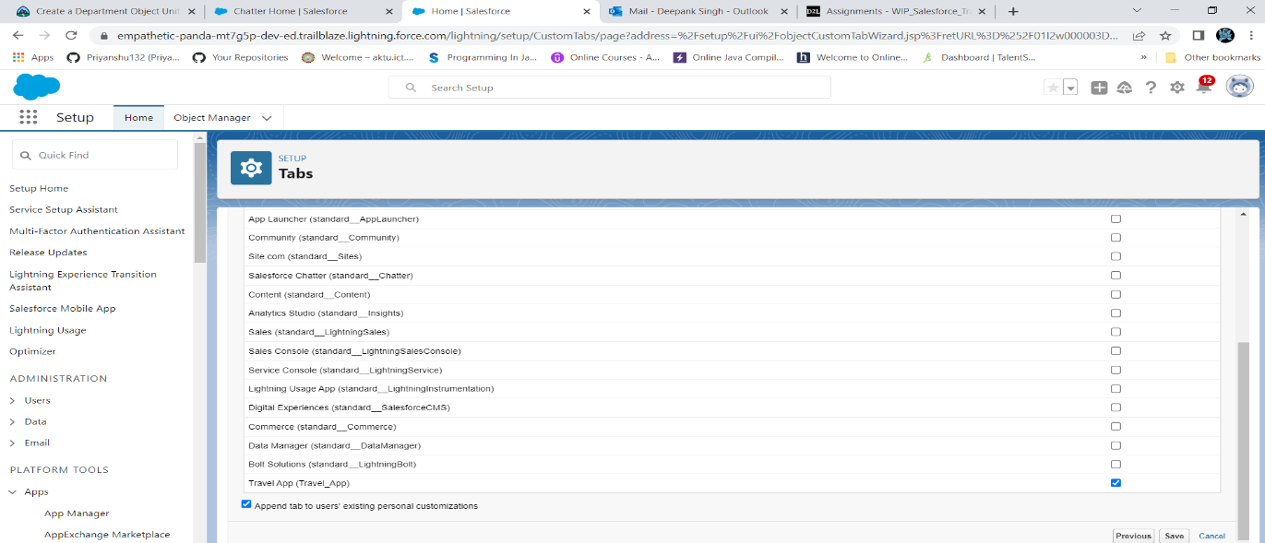

Step3:Creation of Custom fields on department object

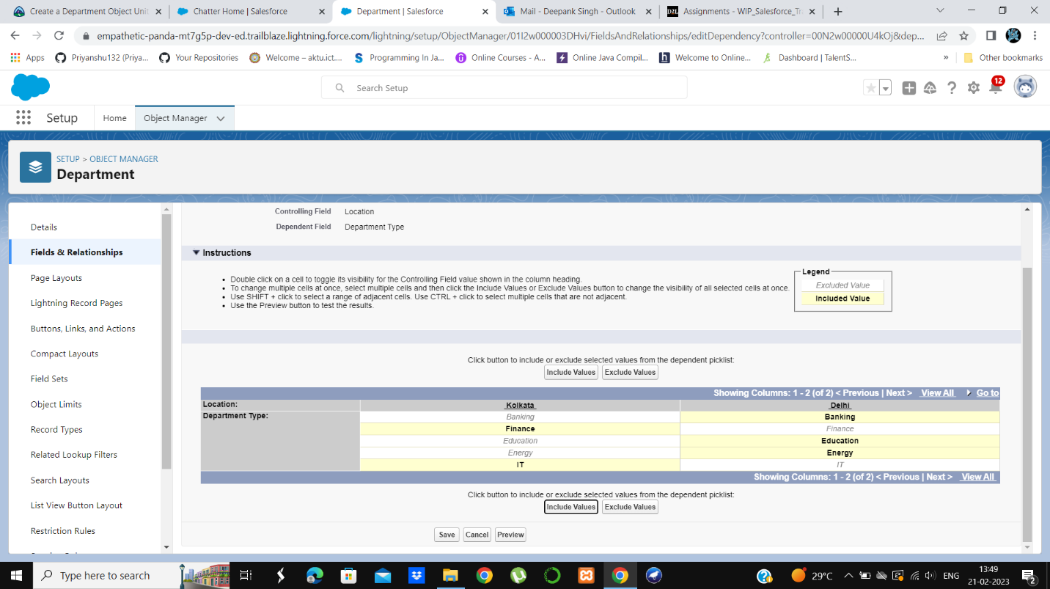

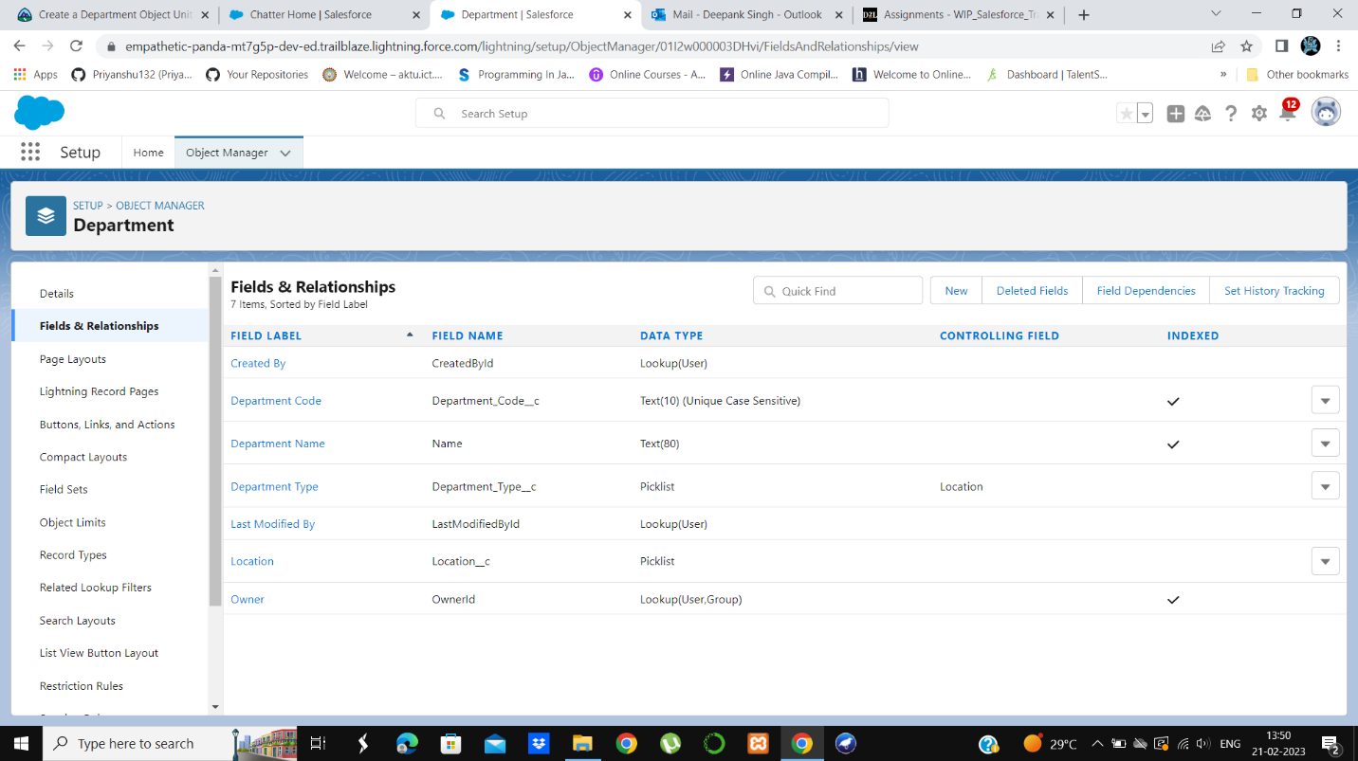

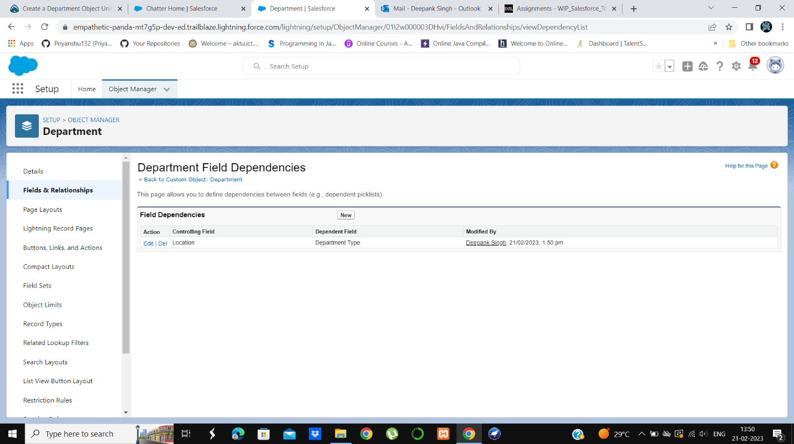

Step4:Creation of Travel approval object

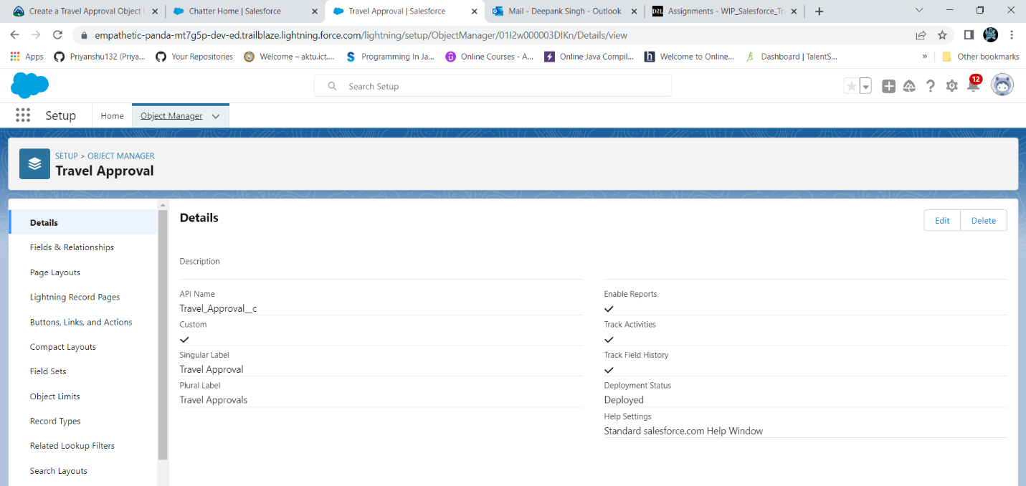

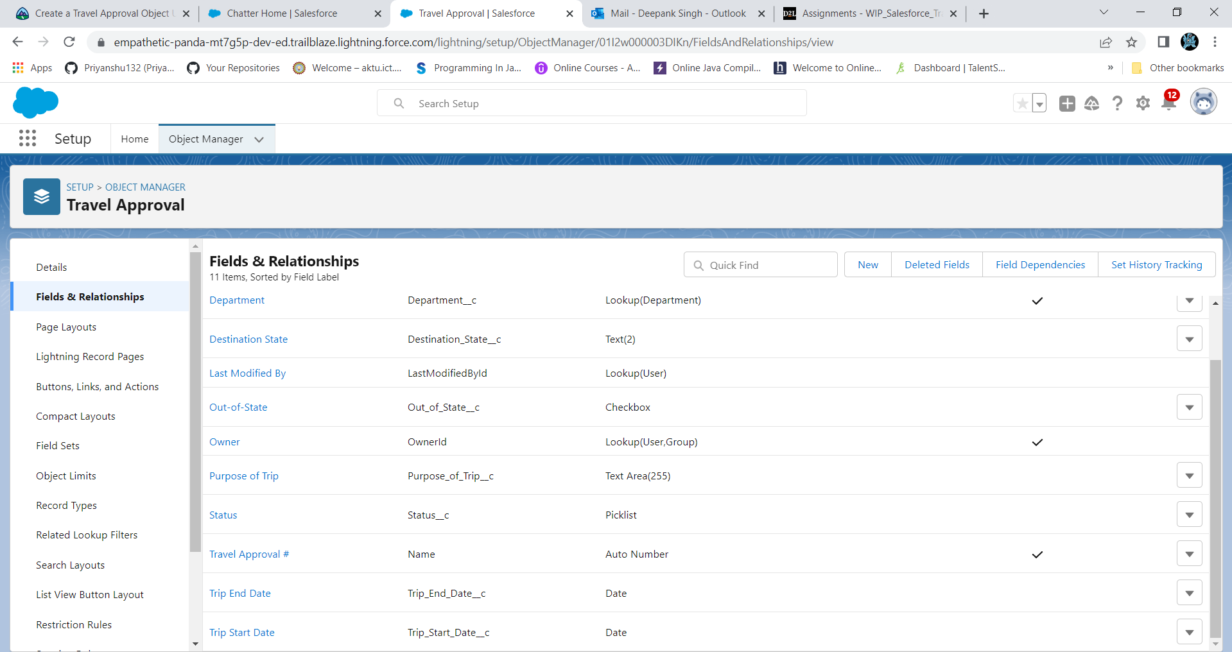

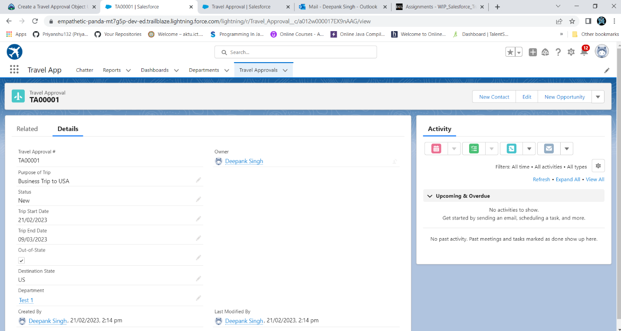

Step5:Import of Department.csv using data import wizard

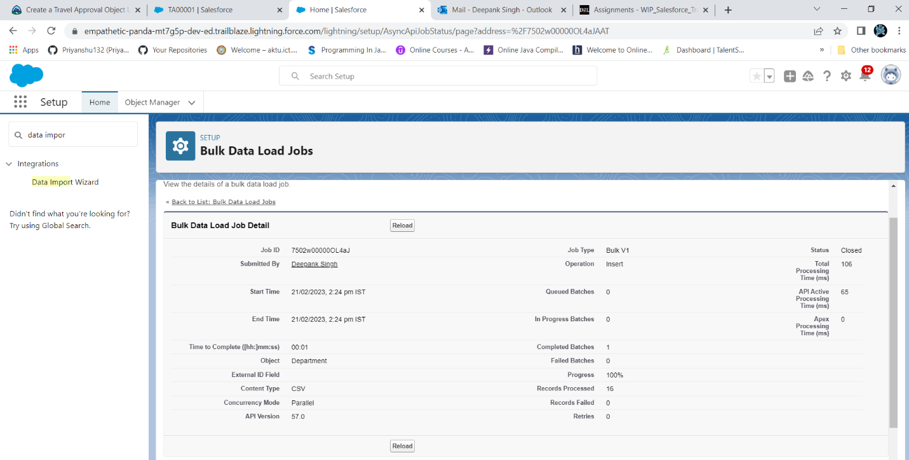

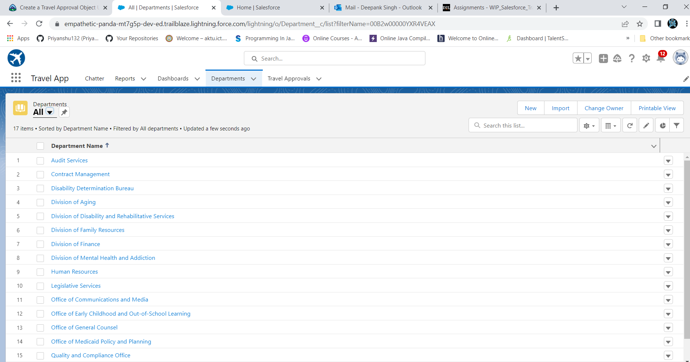

**Module1.exercise2**

Step1:Creation of Travel approval record

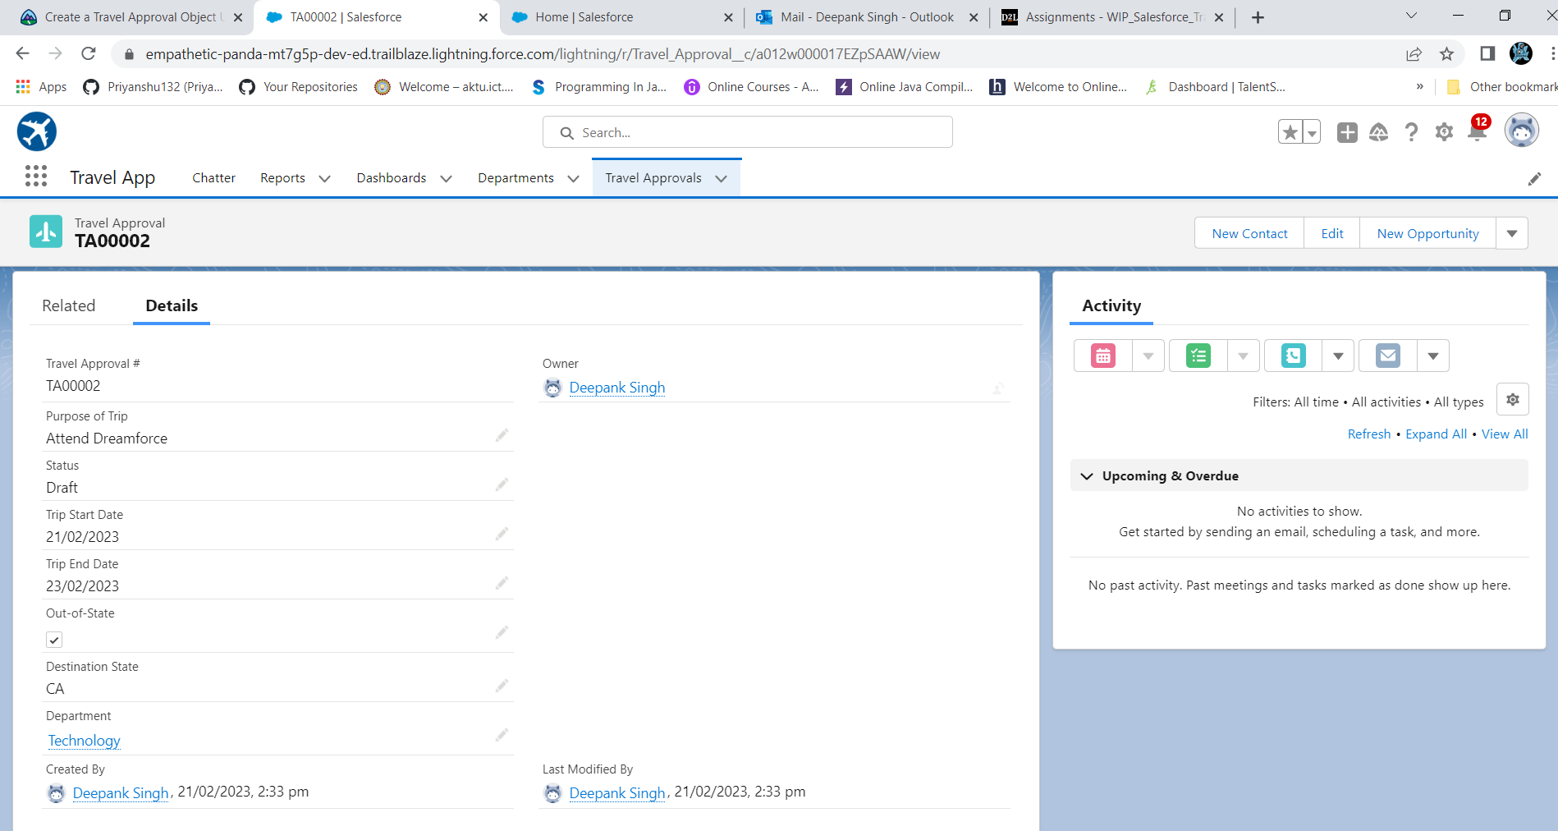

Step2:Creation of Expense object

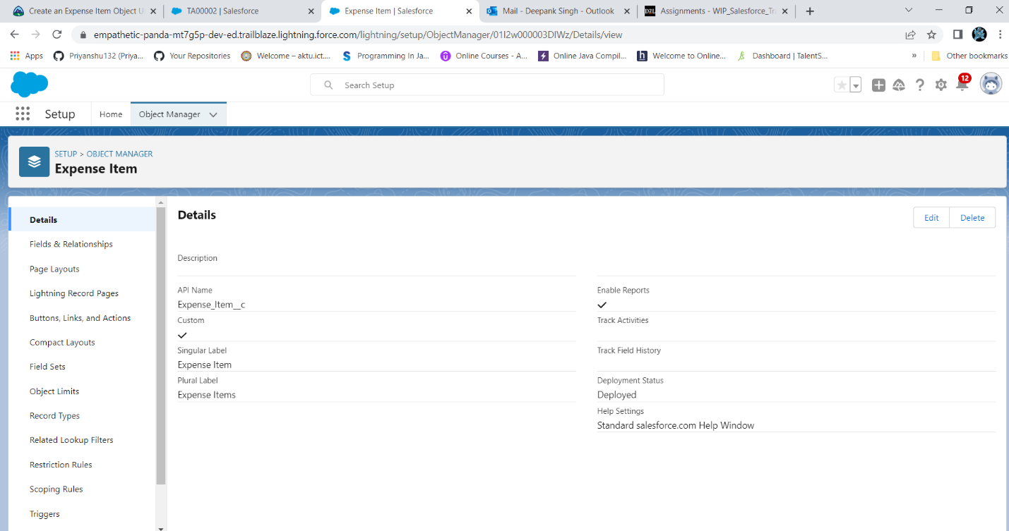

Step3:Creation of Travel approval object

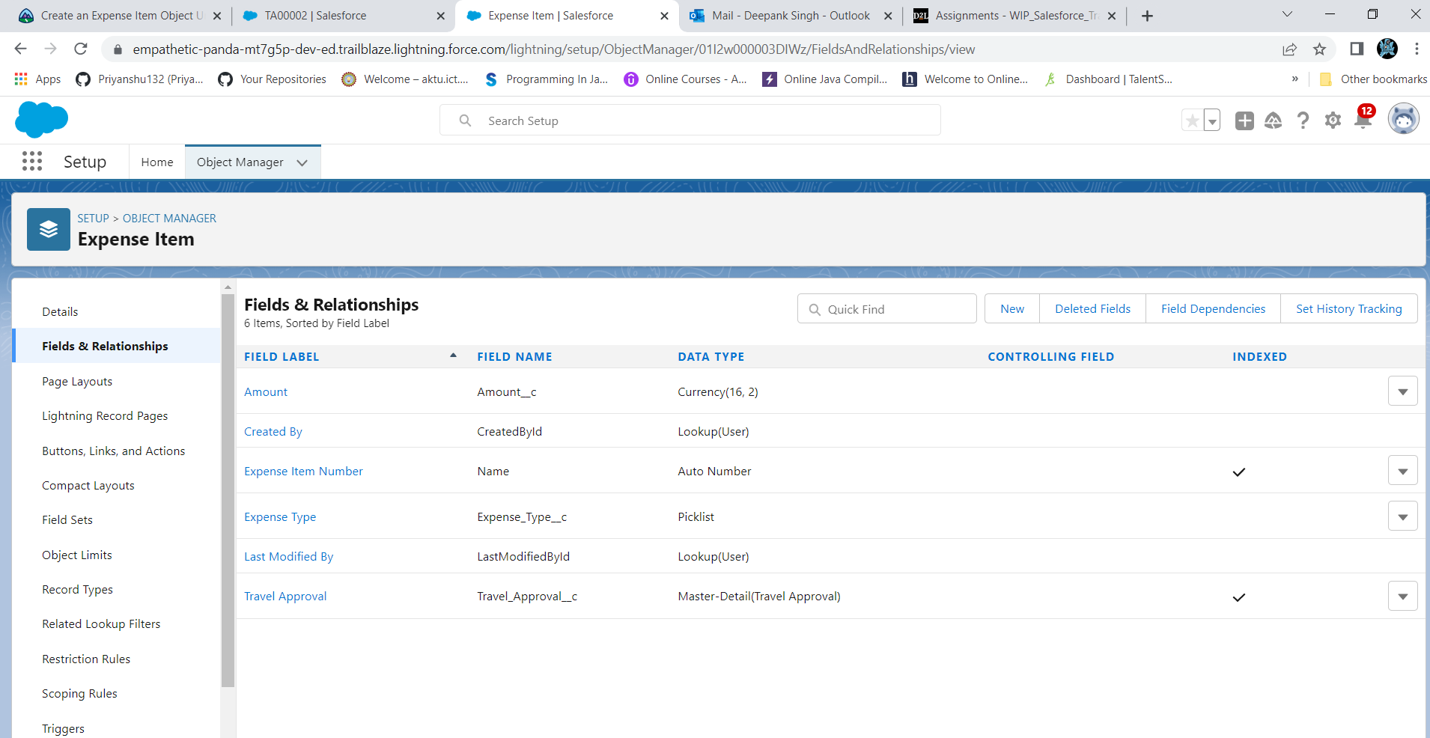

Step4:Creation of Expense Items

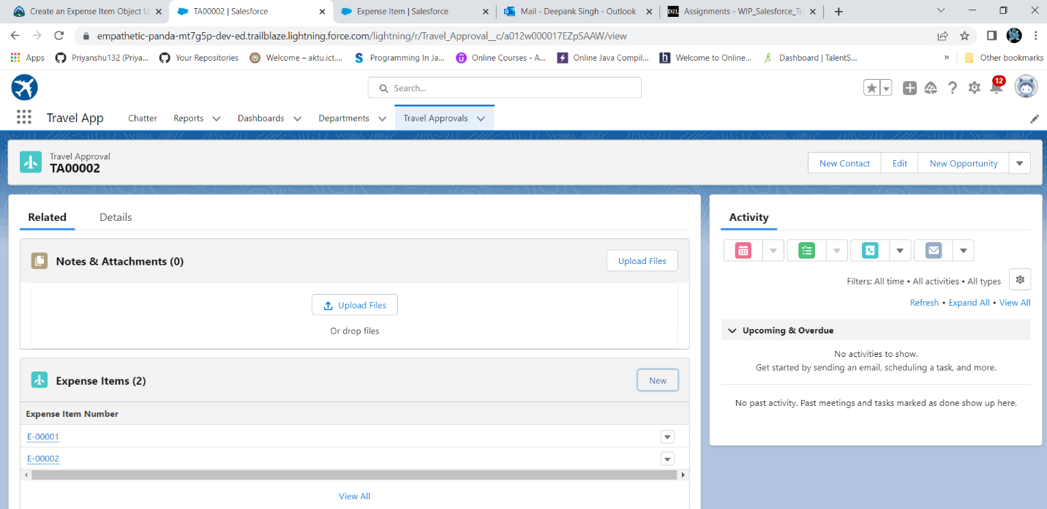

Step5:Creation a User With name Eric Executive

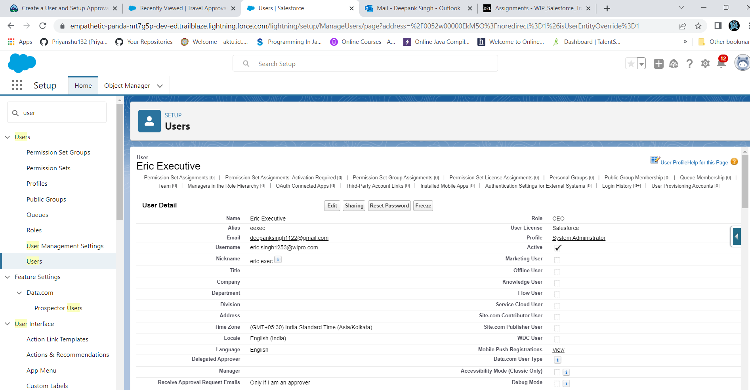

Step6:Add User Eric Executive as manager

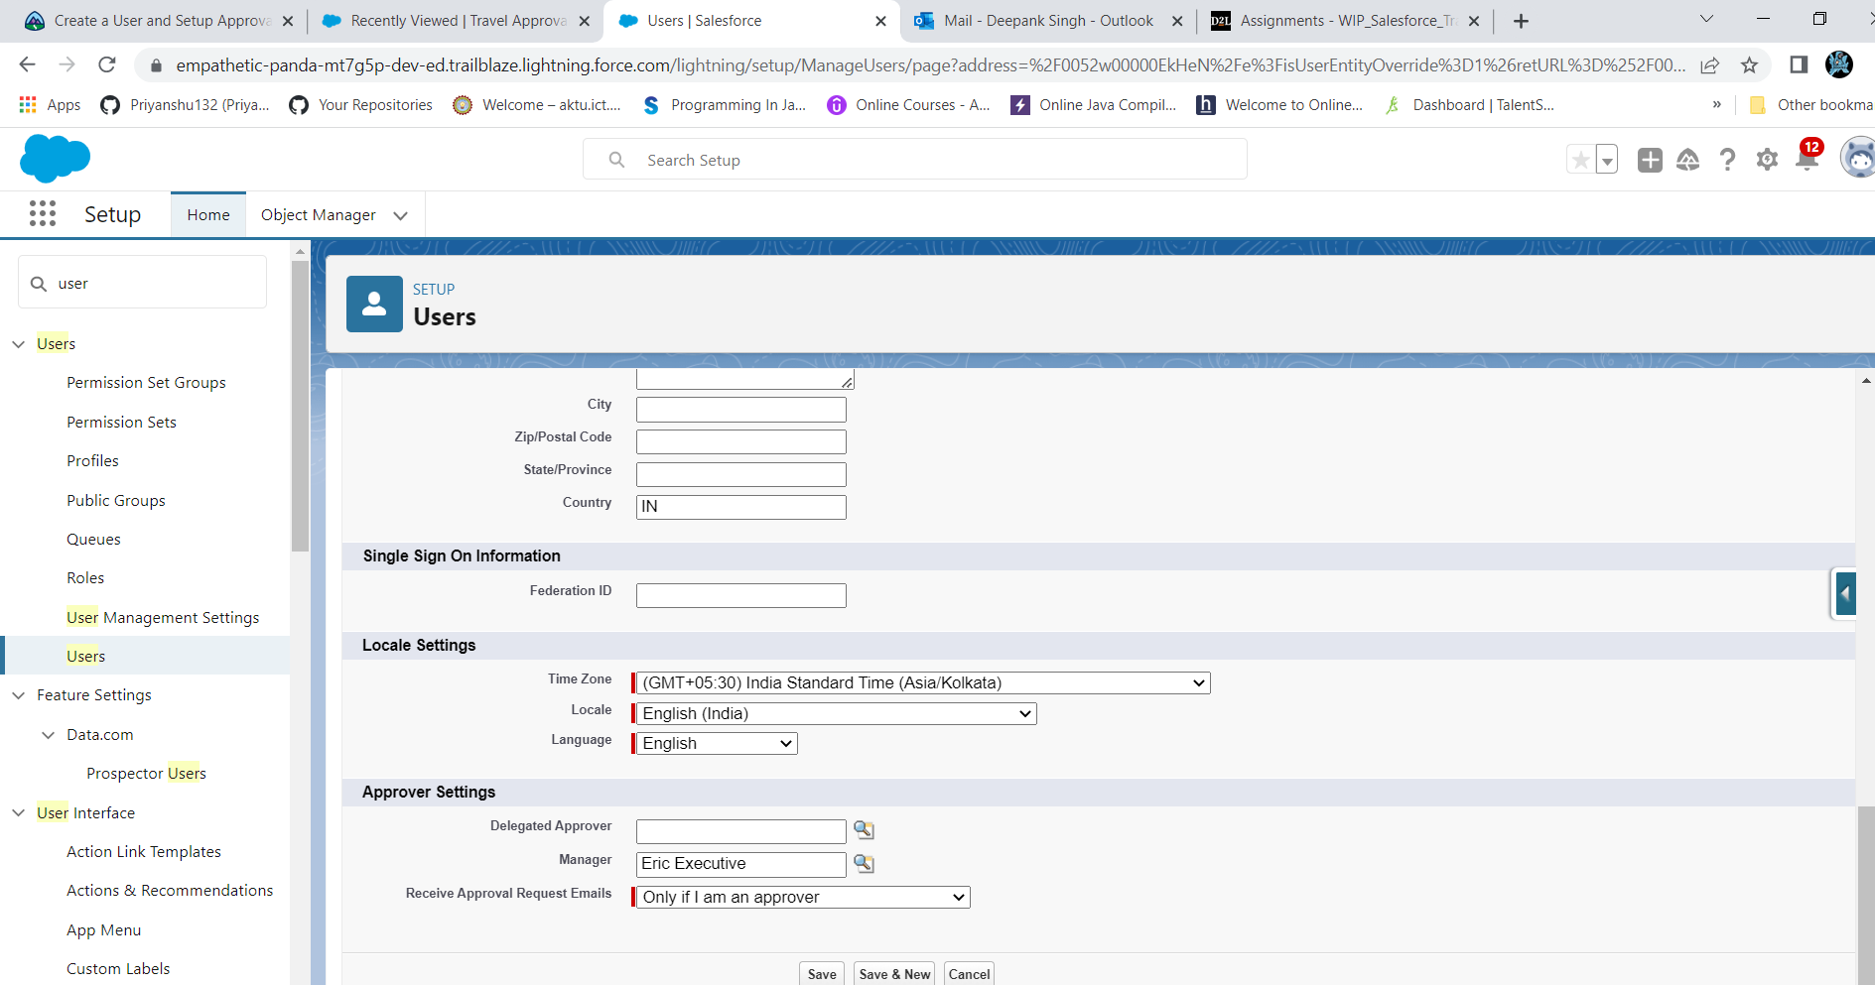

Step7:Customize Travel Approval Default search layout

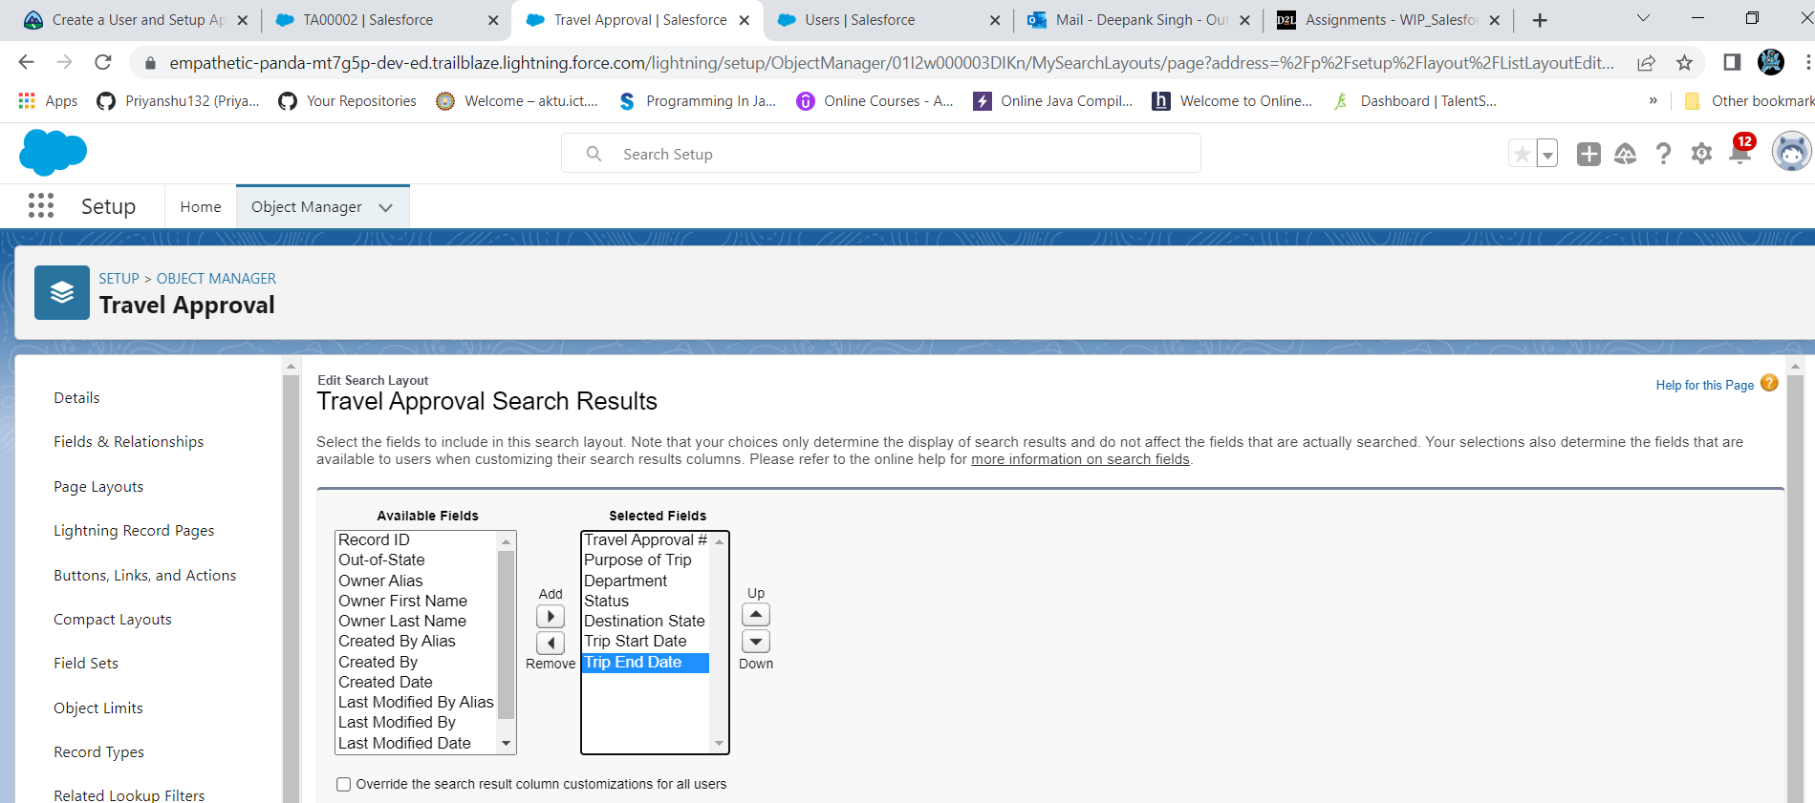

Step8:Select fields to display in travel approval “ALL” List view

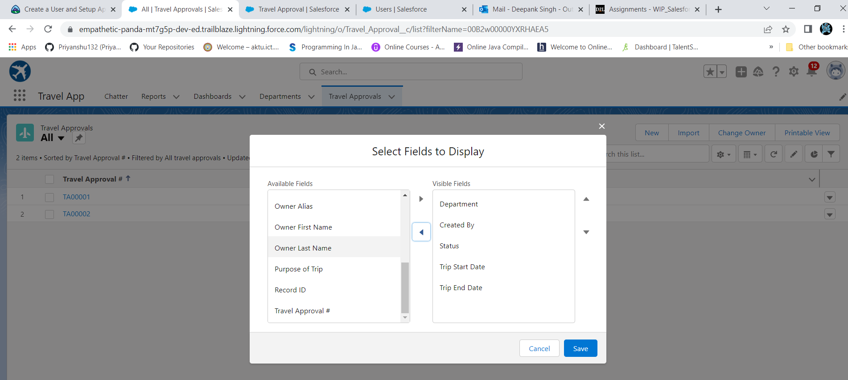

Step9:Creation of custom list view “Open Out of State Travel Requests”

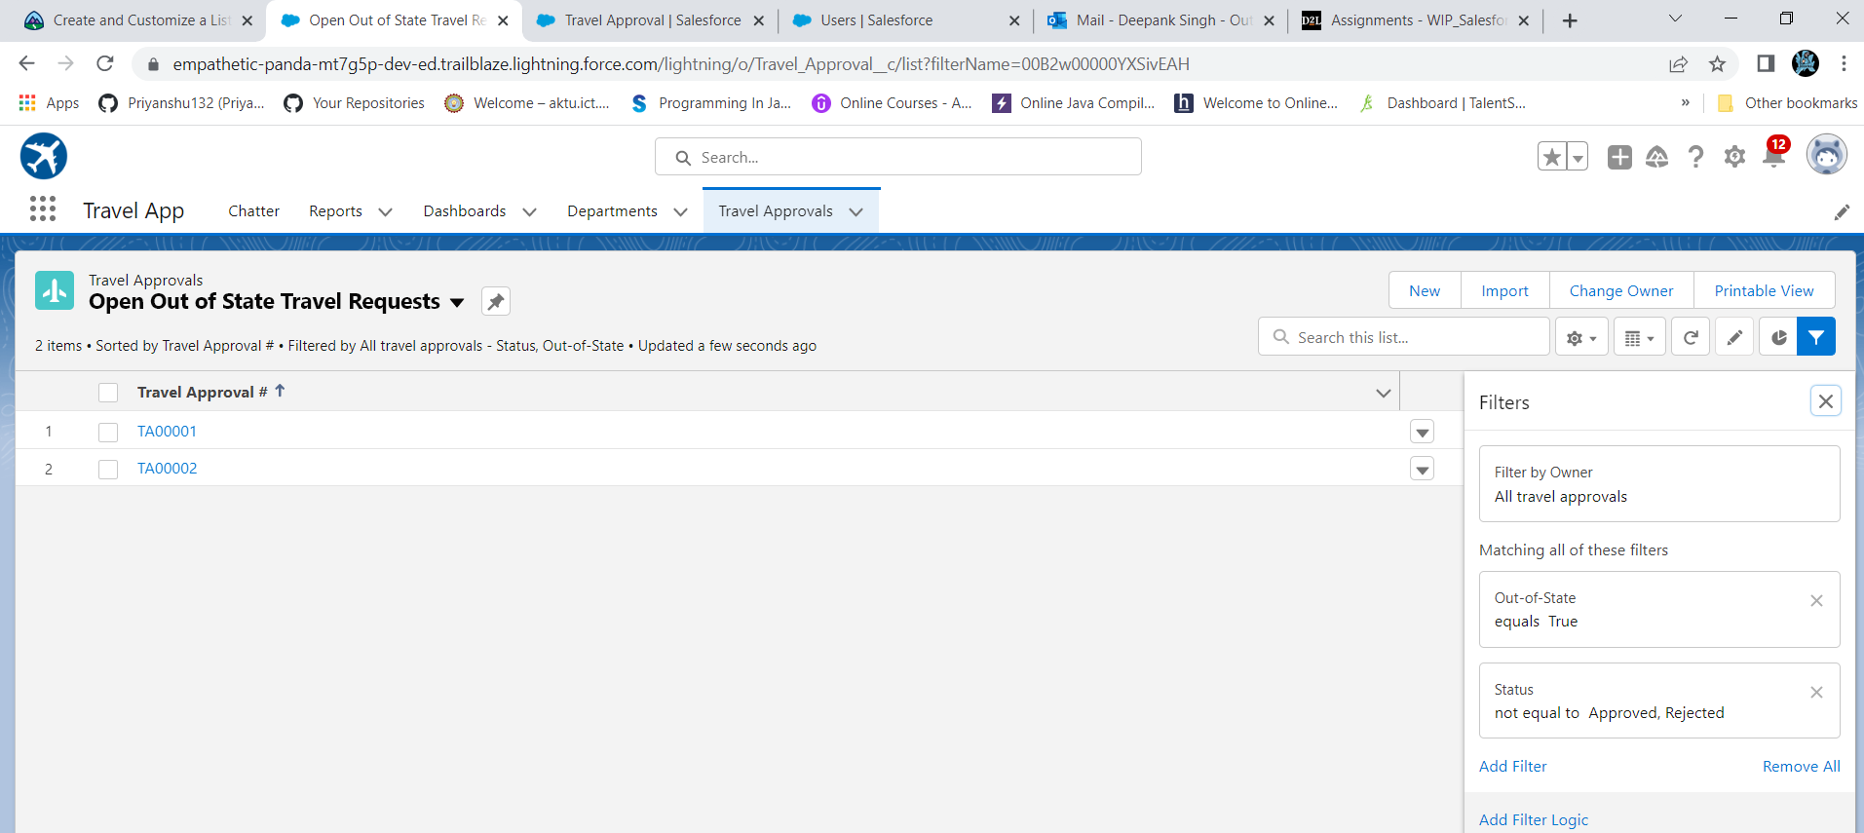

Step10:Select fields to Open out of state travel requests list view

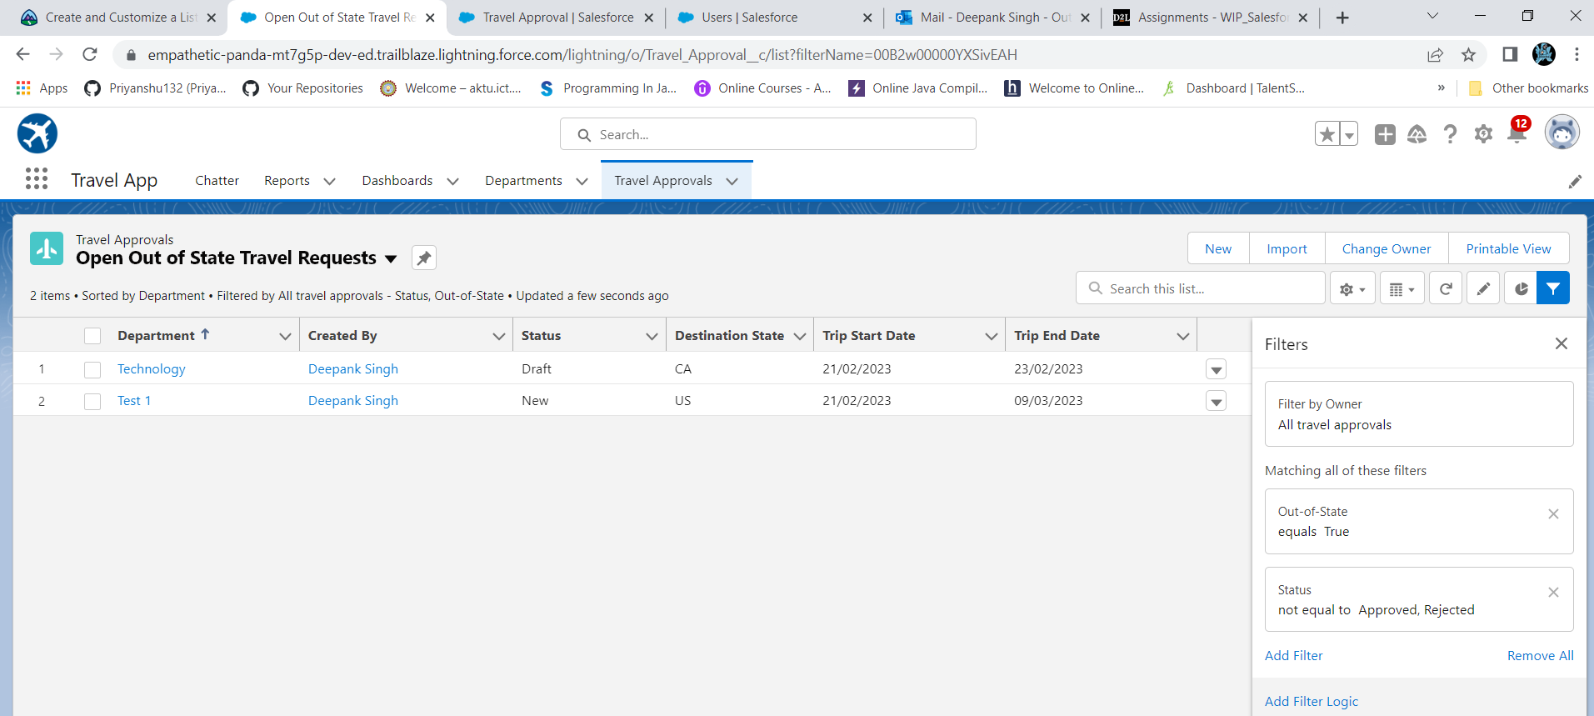

Step11:Customize of Travel approval Page layout

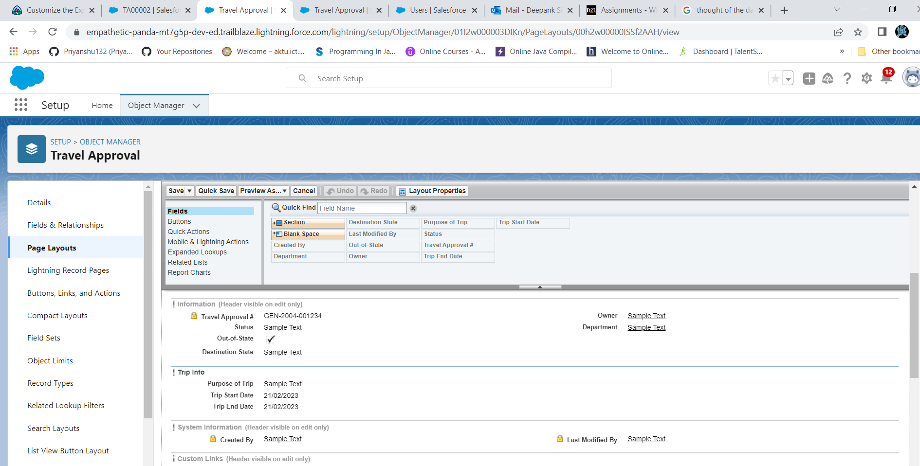

Step12:Customize the expense item related list under travel approval page layout

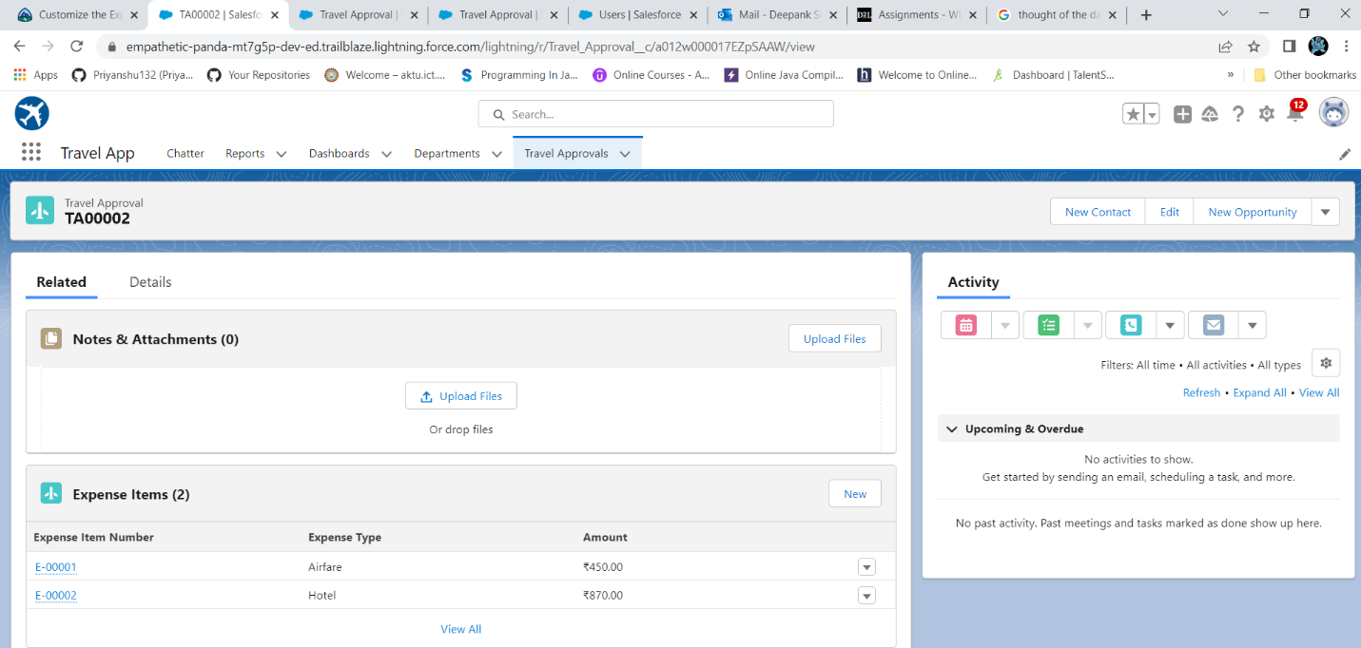

Step13 :Enable of chatter and feed tracking for Travel approval object

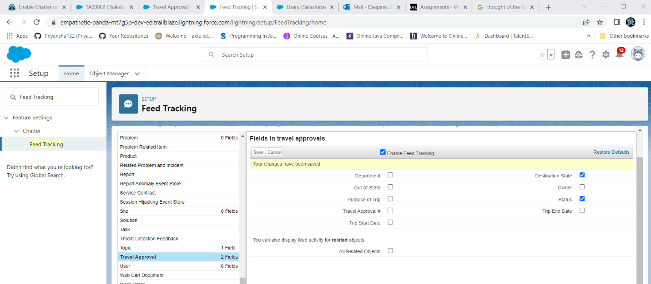

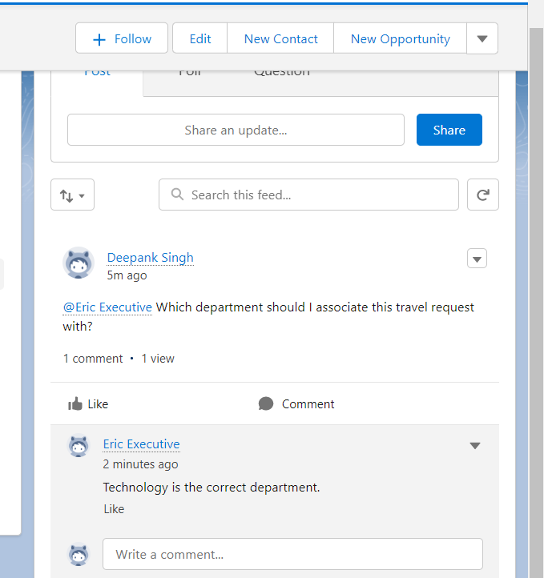

**Module2.exercise1**

Step1:Create a validation rule on travel approval object

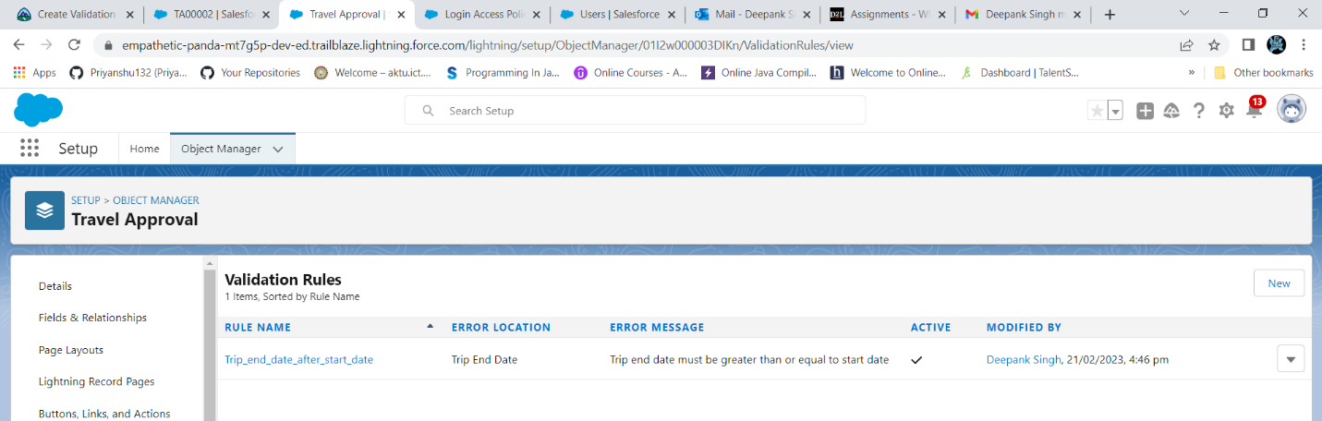

Step2:Create a Roll up Summary field on travel approval object

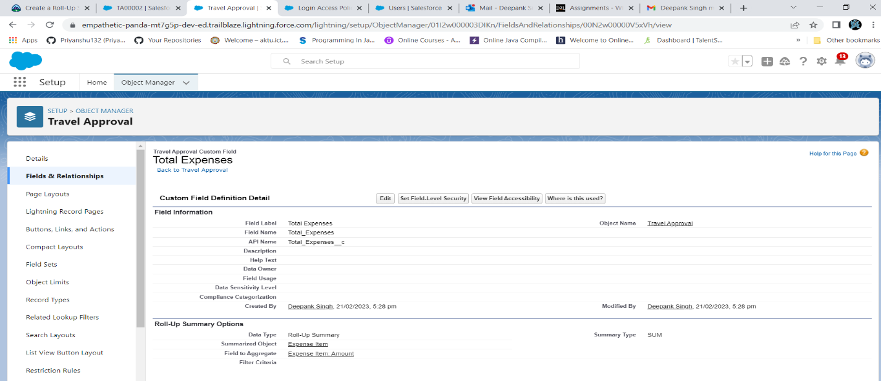

Step3:Create Formula Fields using Static Resource

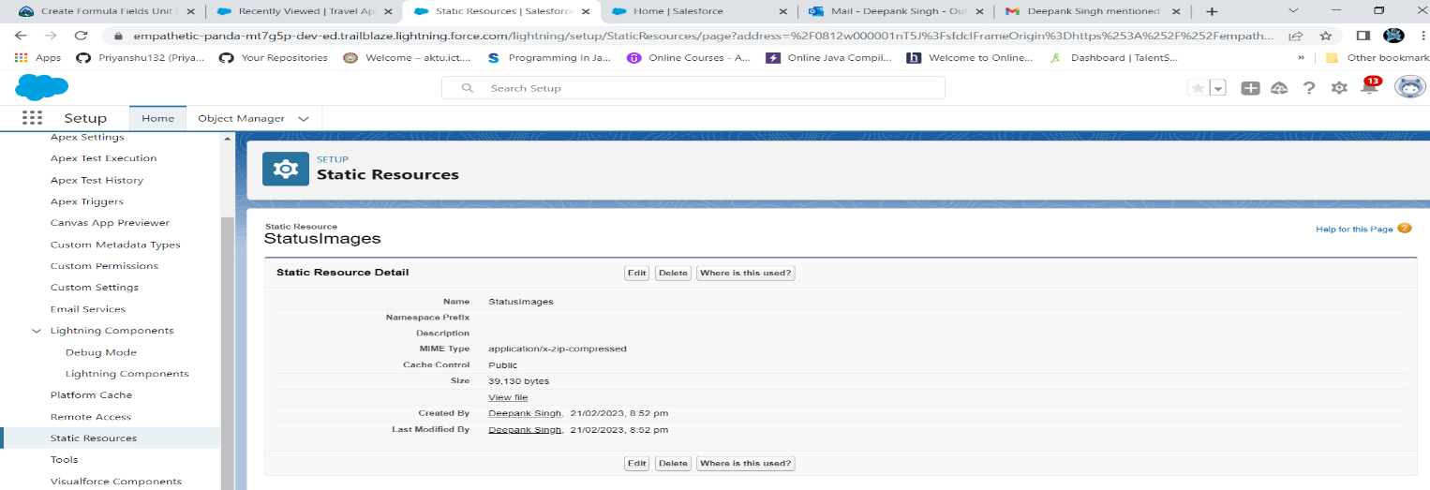

Step4:Create Formula Fields on travel Approval object to show an image based on the status field

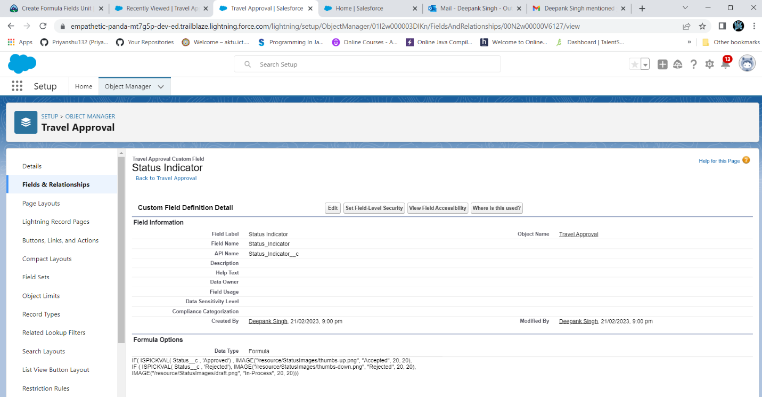

Step5:Create a Record-Triggered Flow

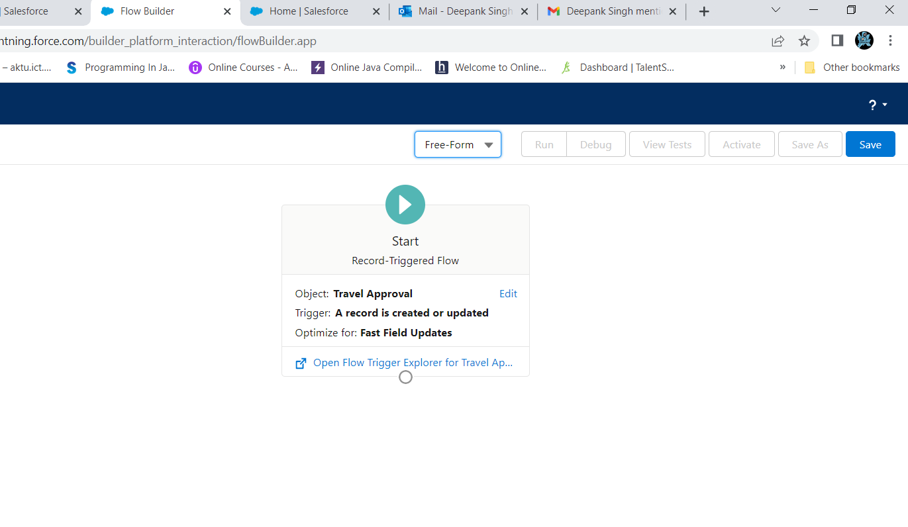

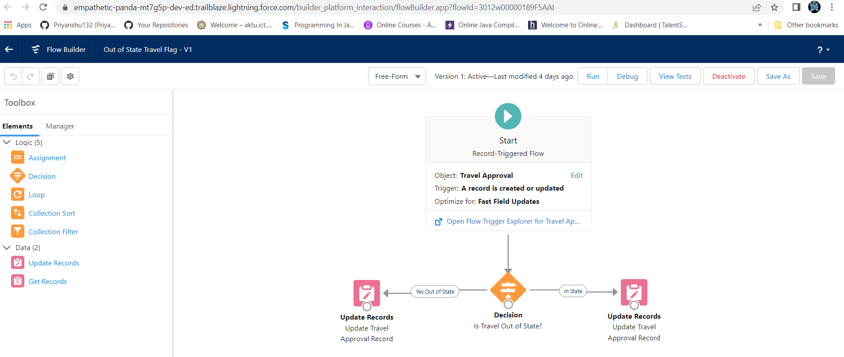

Step6:Create a Approval process to send travel approvals to manager or travel coordinator.

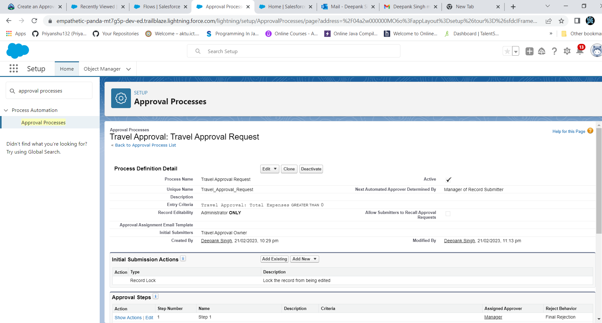

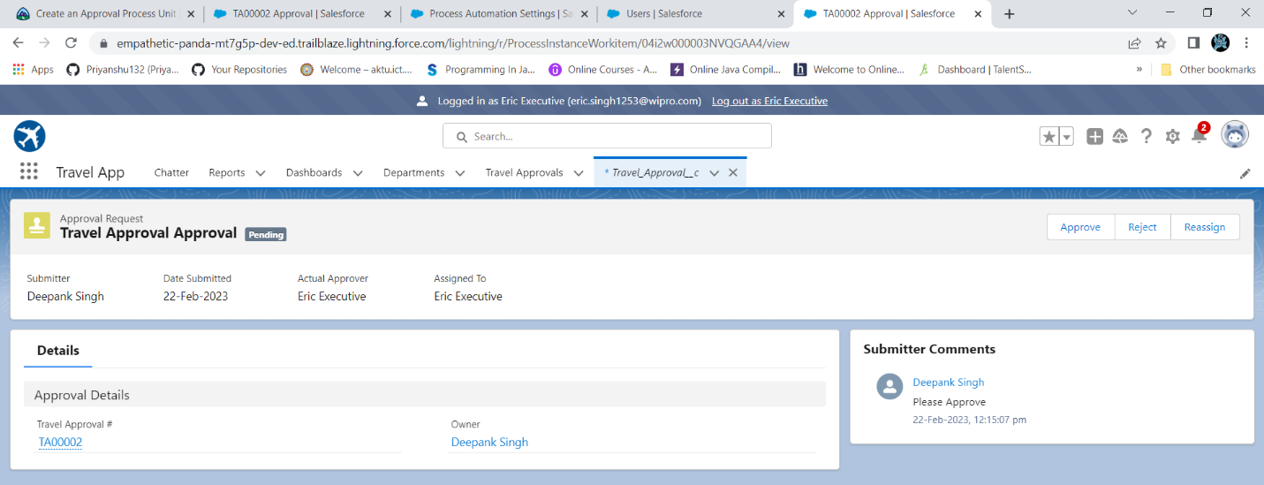

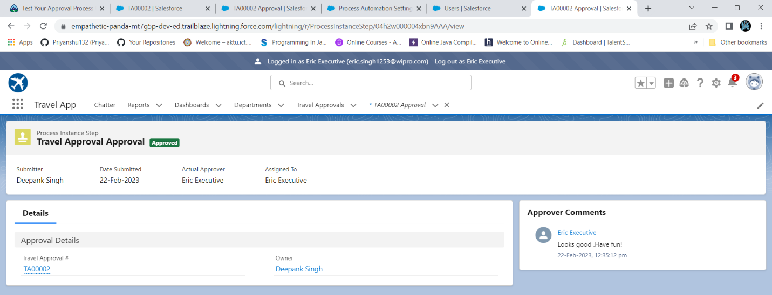

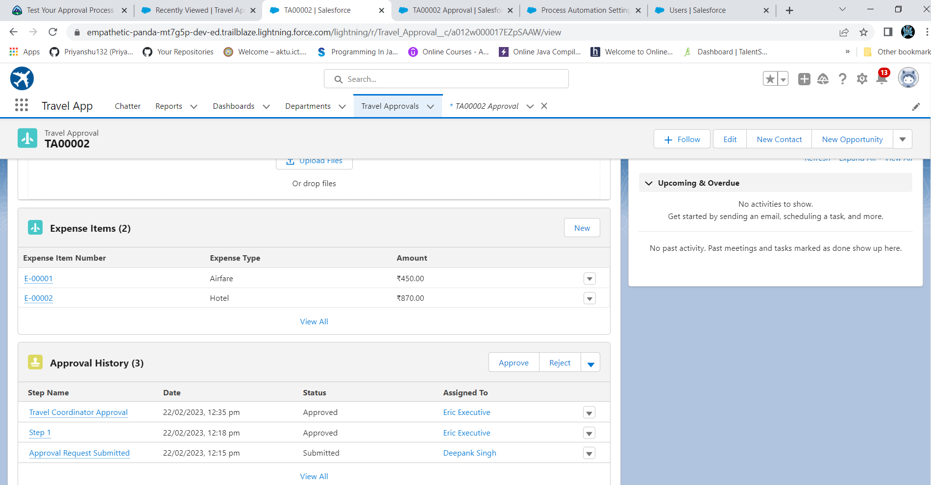

**Module2.exercise2**

Step1:Use Data import wizard to import Travel Approval records.

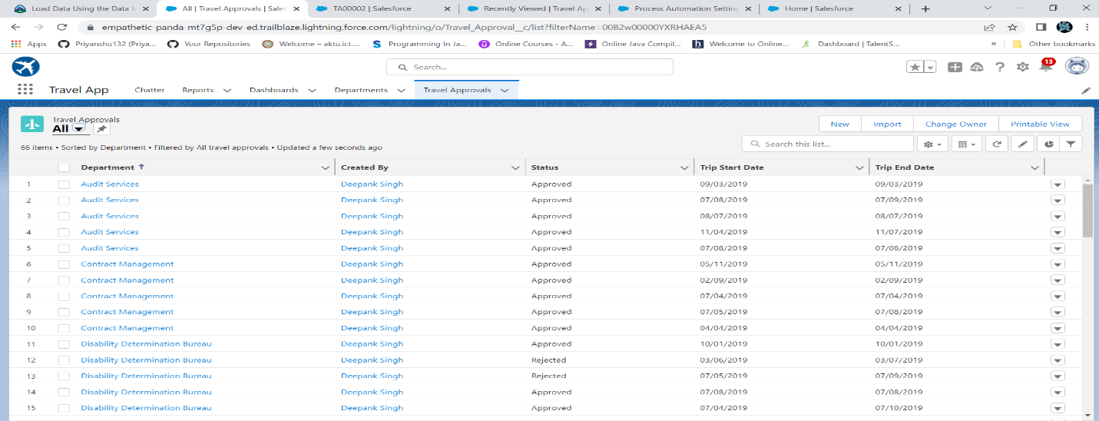

Step2:Create a Travel requests by department report Using Report type:Travel Approvals.

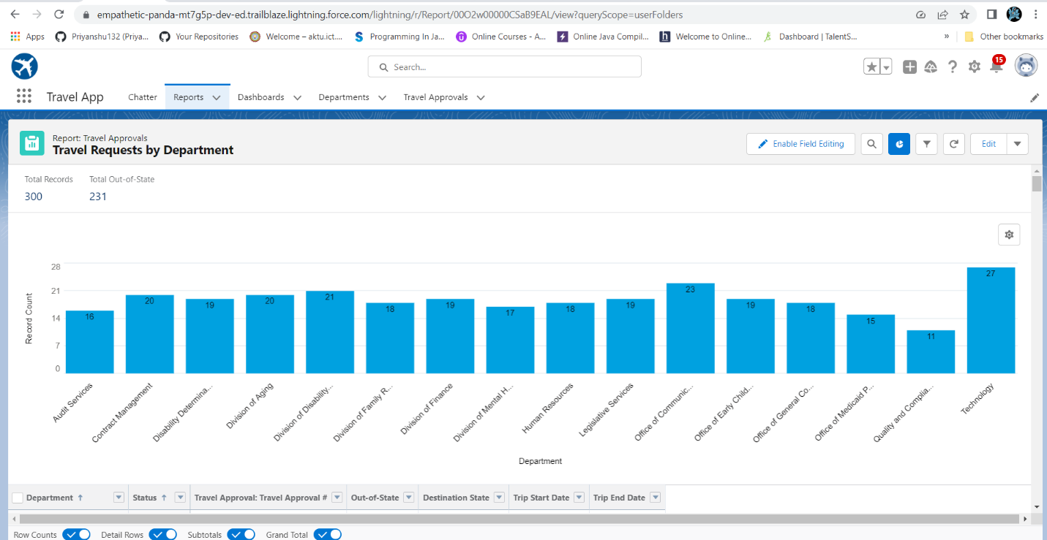

Step3: Create a Travel requests by Month report Using Report type:Travel Approvals.

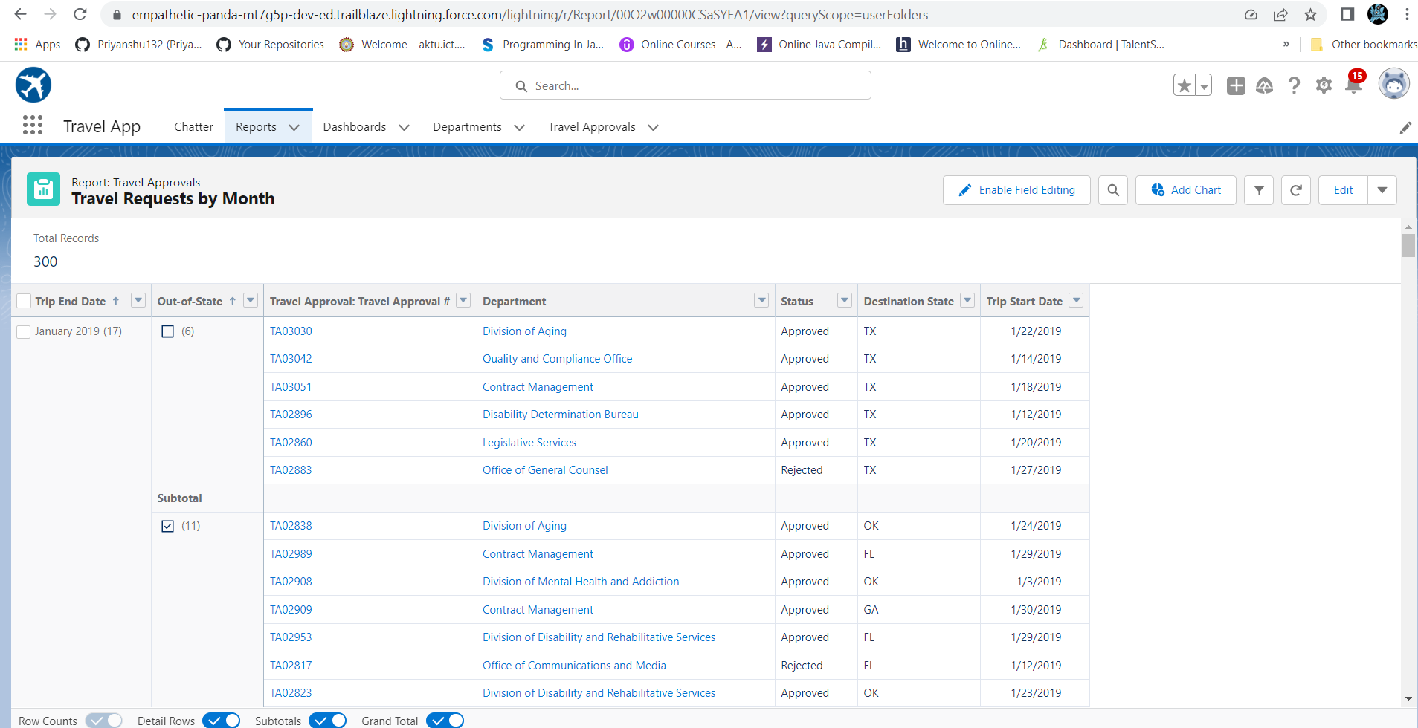

Step4: Create a Travel Approvals Dashboard

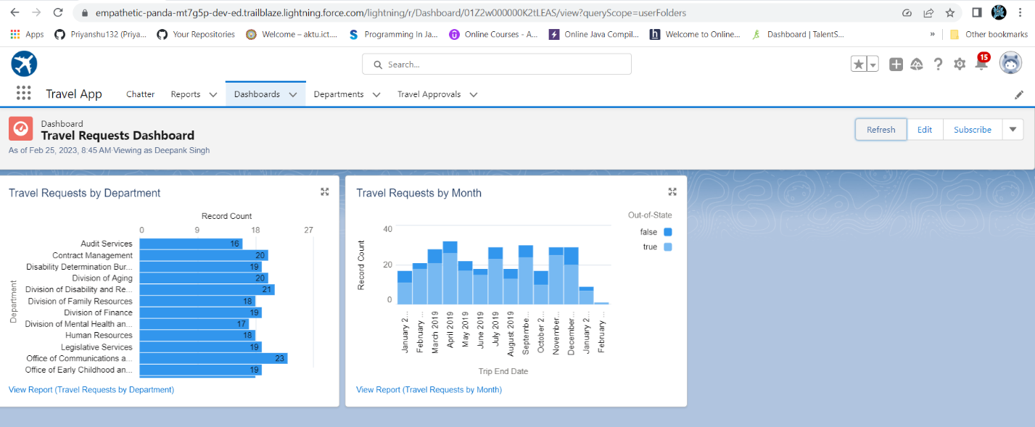

**Module3.exercise1**

Step1: Create a new custom Lightning App Name: Code Playground

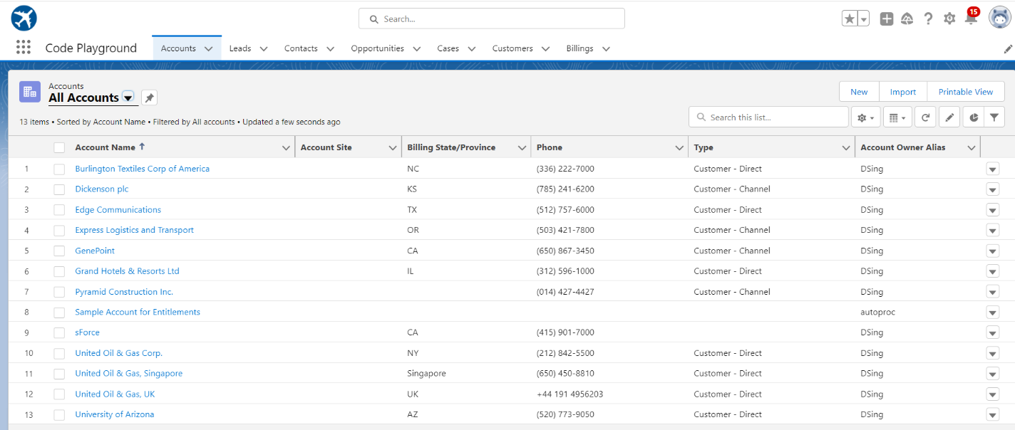

**Module3.exercise2**

Use Execute Anonymous to define and execute the following code:

1. Define a String Variable & use string method ‘endsWith’ to display the output.

* Code and output:

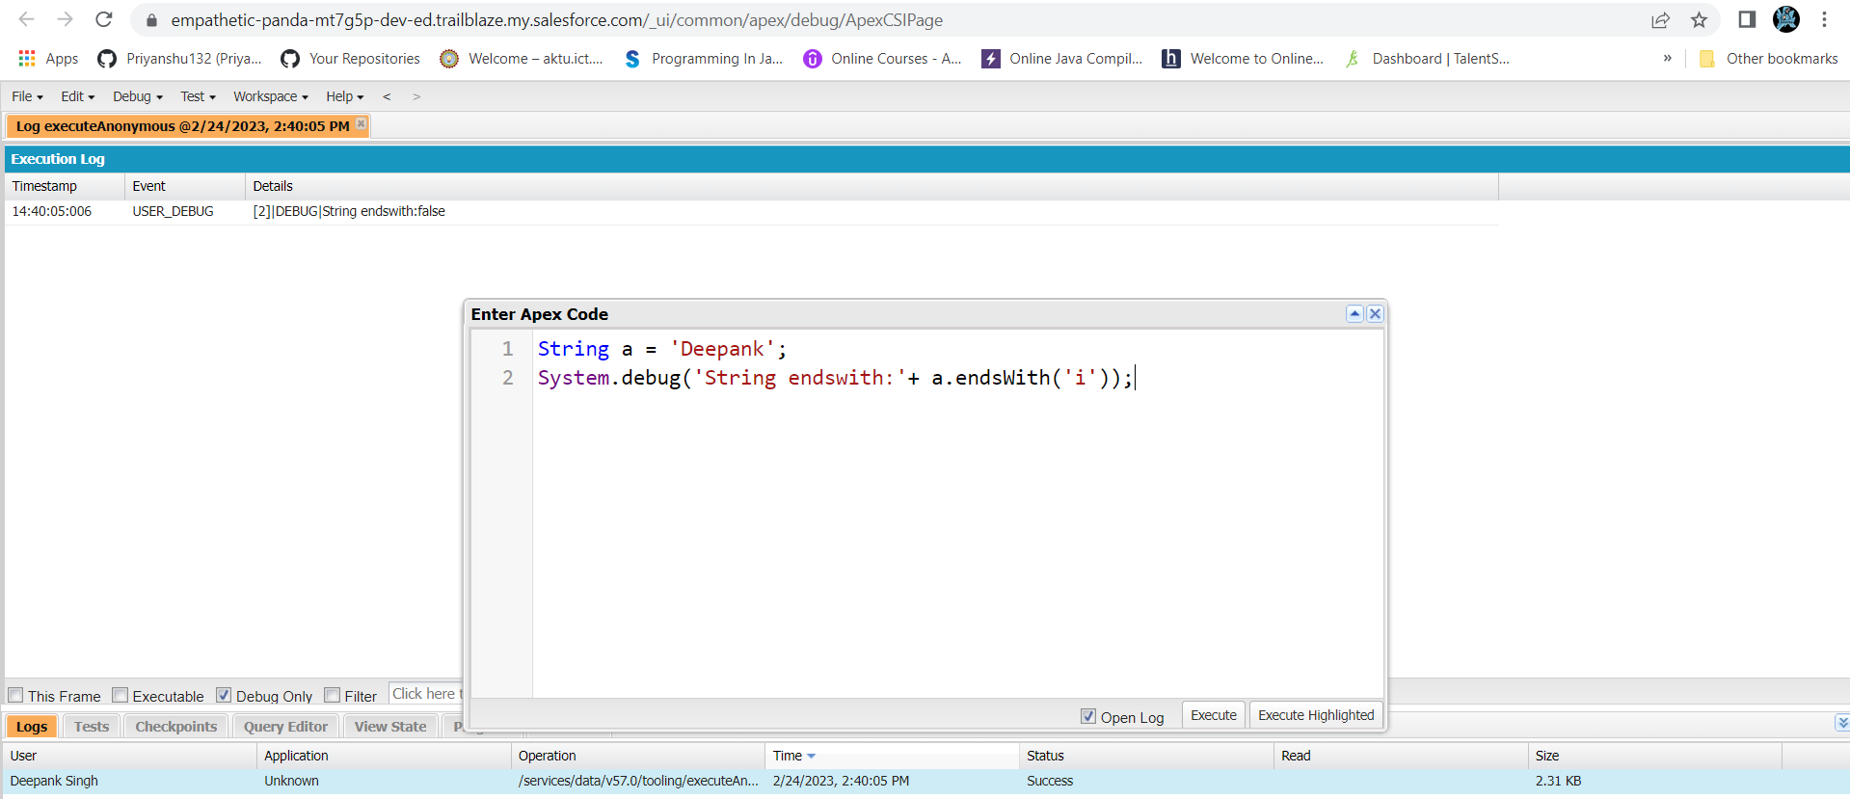

2. Define 2 Date type variables, use Date method today() & addDays(30) to display the output.

* Code and output:

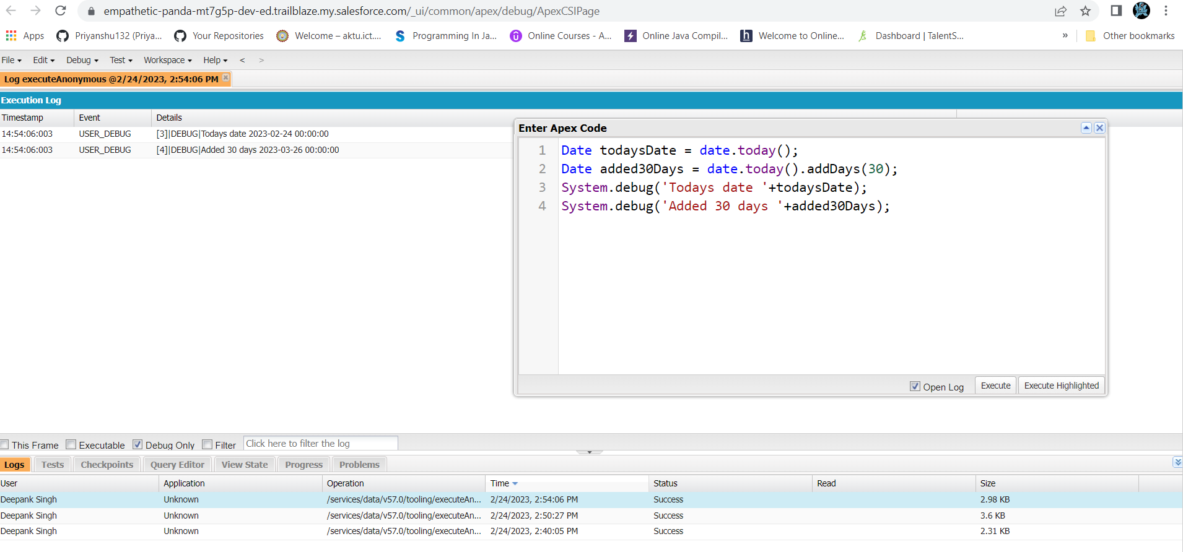

3. Display the output of an Integer variable from string ‘10’ and then add 20 to it.

* Code and output:

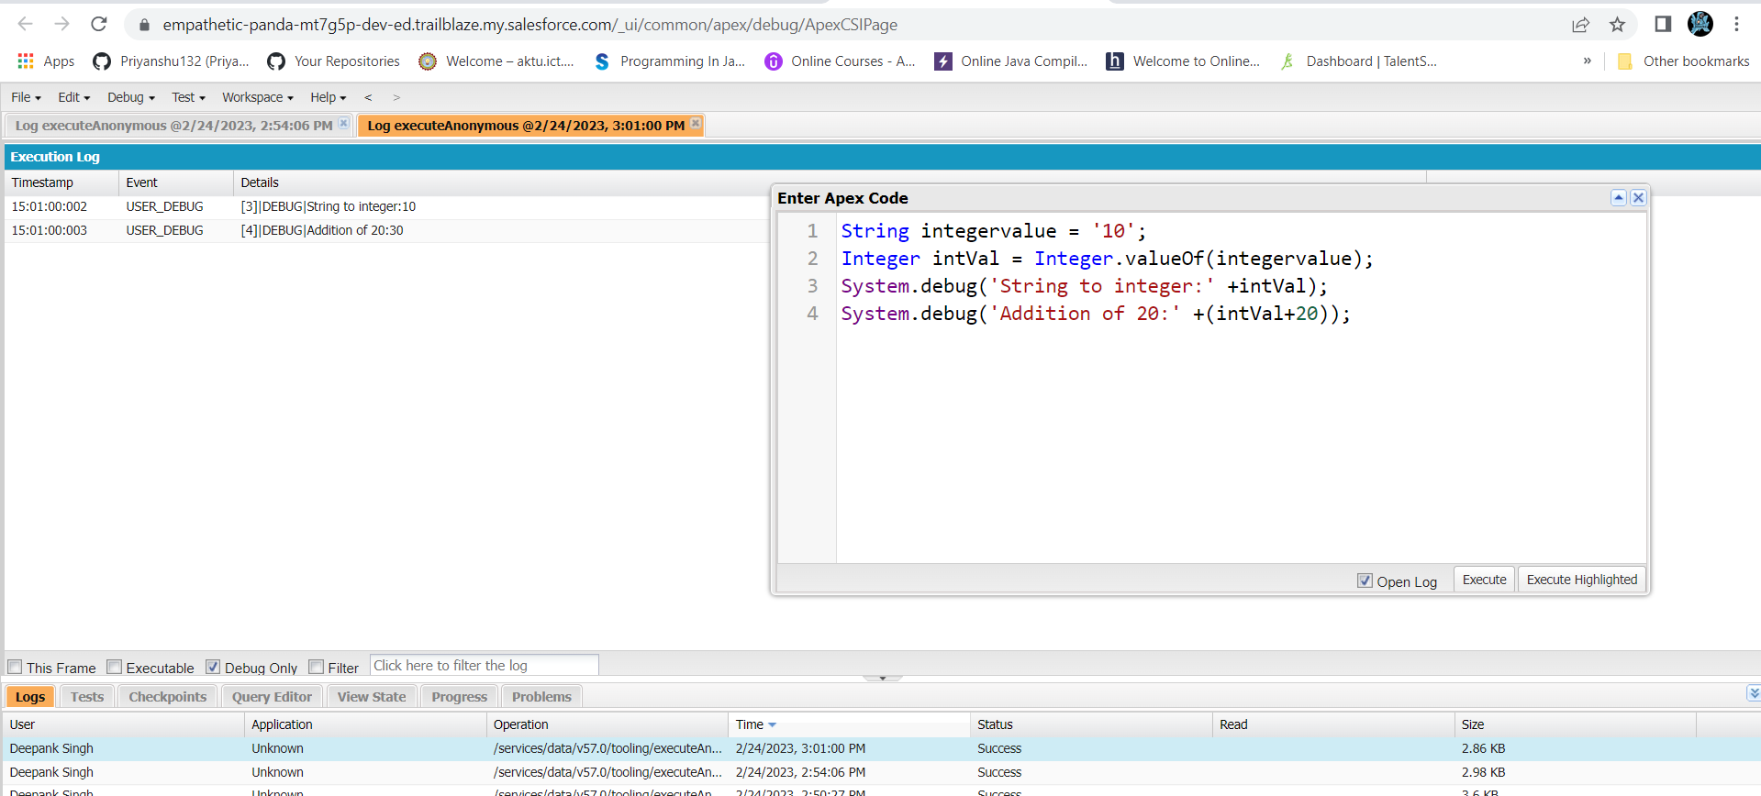

4. Define a String Variable & use string method length() to display the output.

* Code and output:

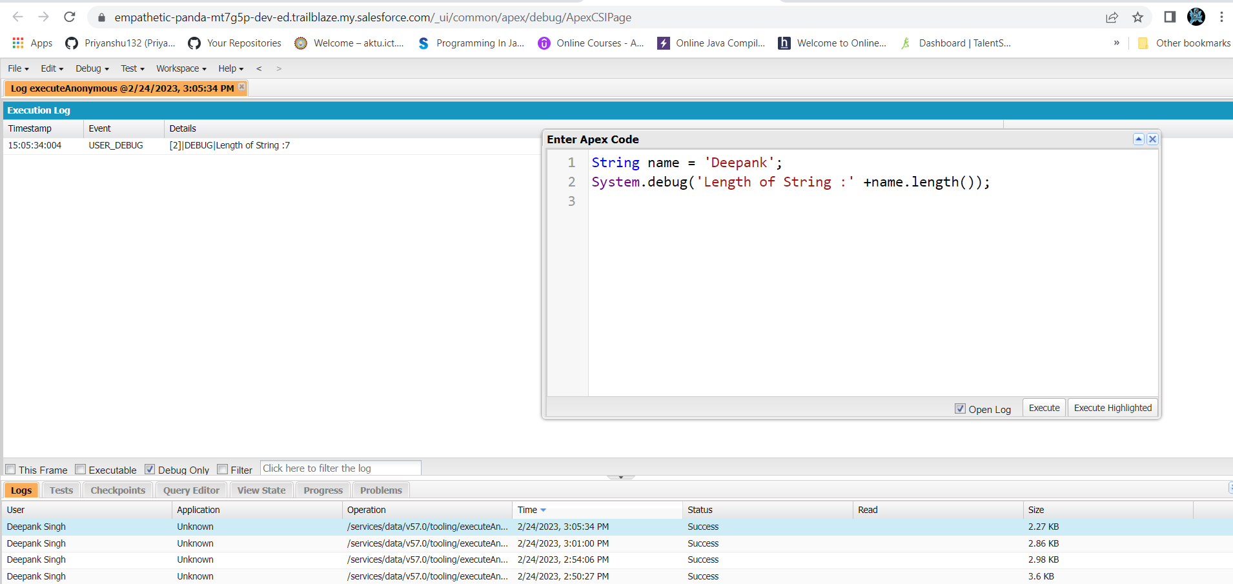

5. Define a List of integer and Code and output: display the output using add(), get(), set(), clear(), methods.

* Code and output:

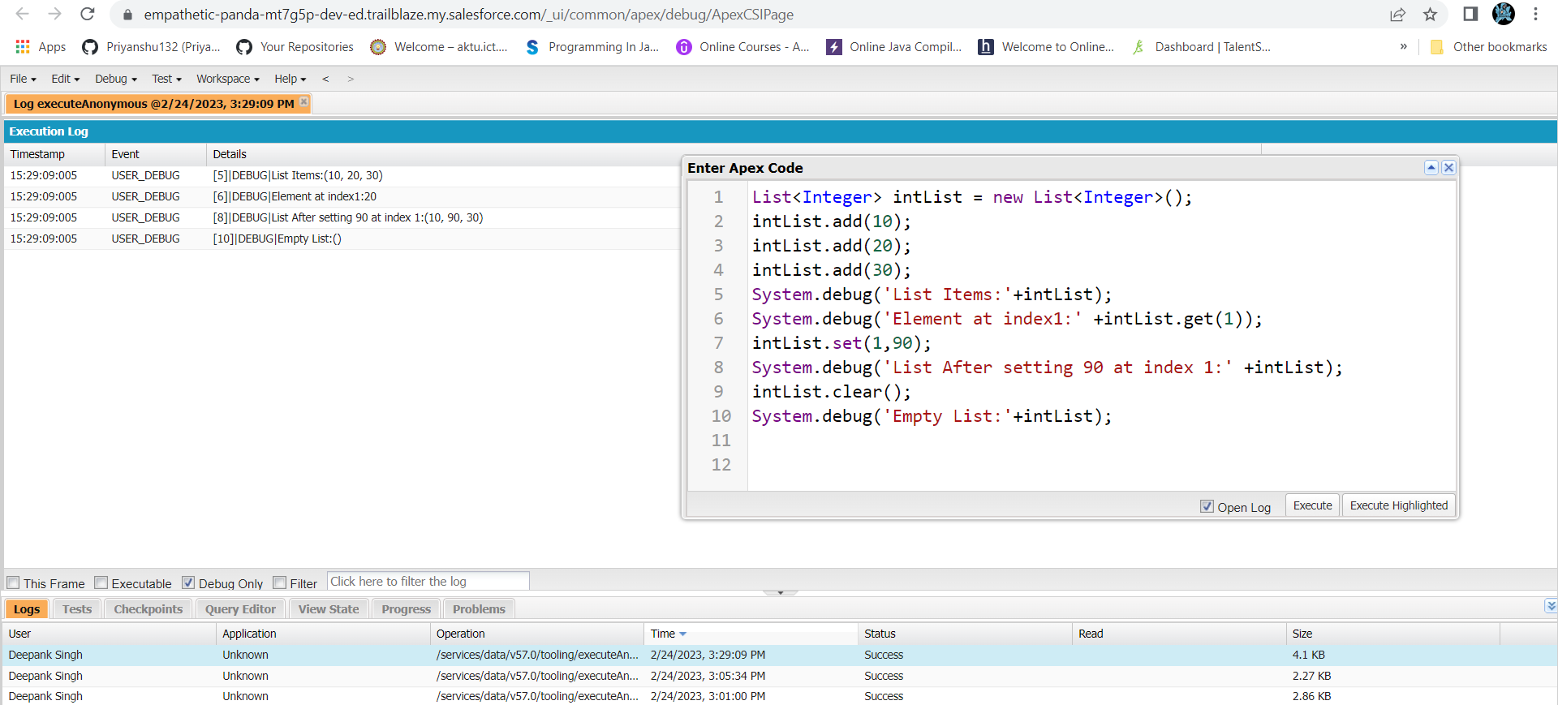

**Module3.exercise2**

Use Execute Anonymous to define and execute the following code to display the value of x = 0 to 9.

* Code and output:

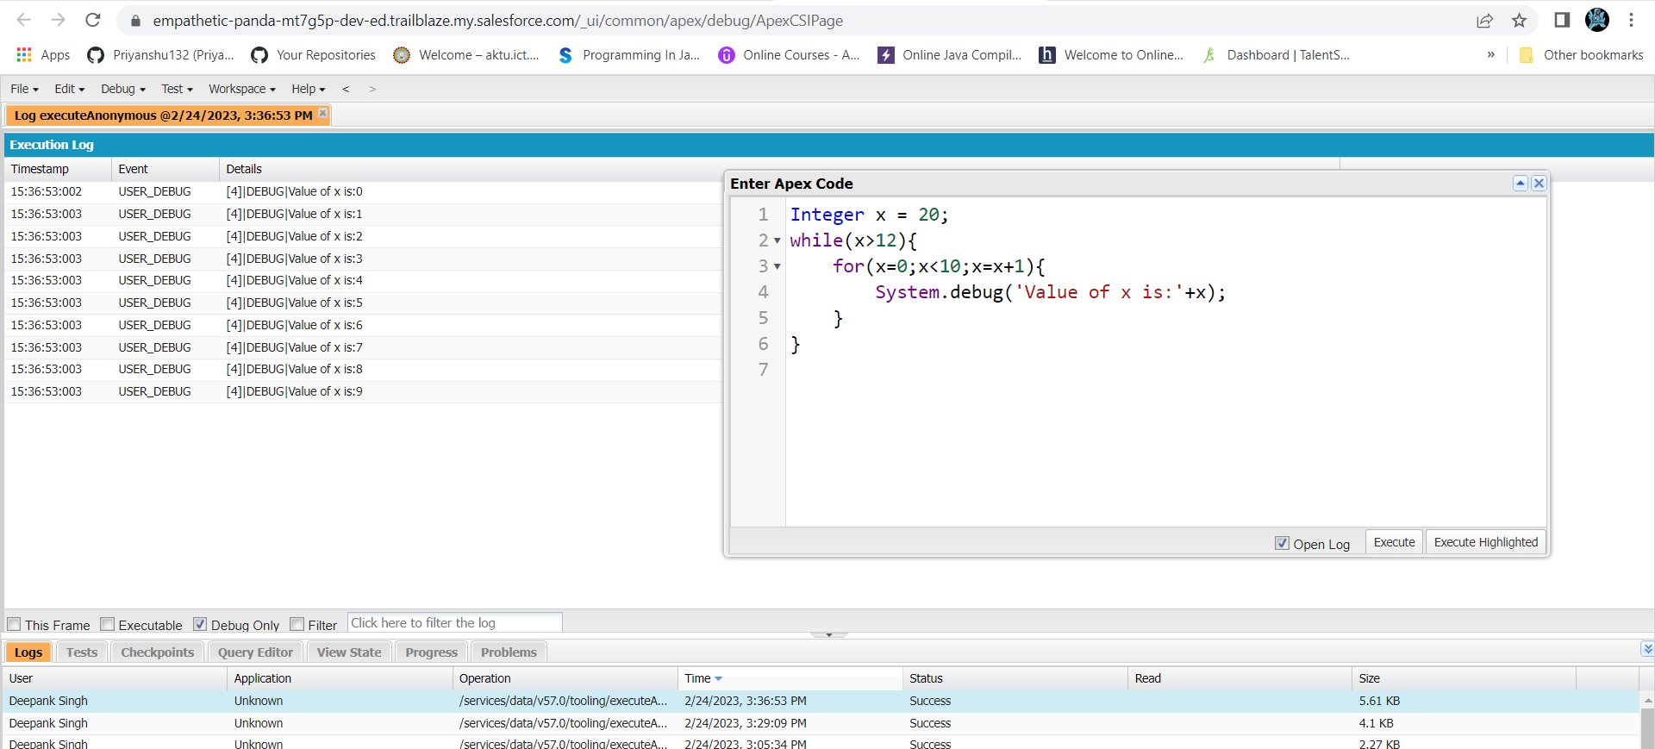

Exercise 3:-

* Code and output:

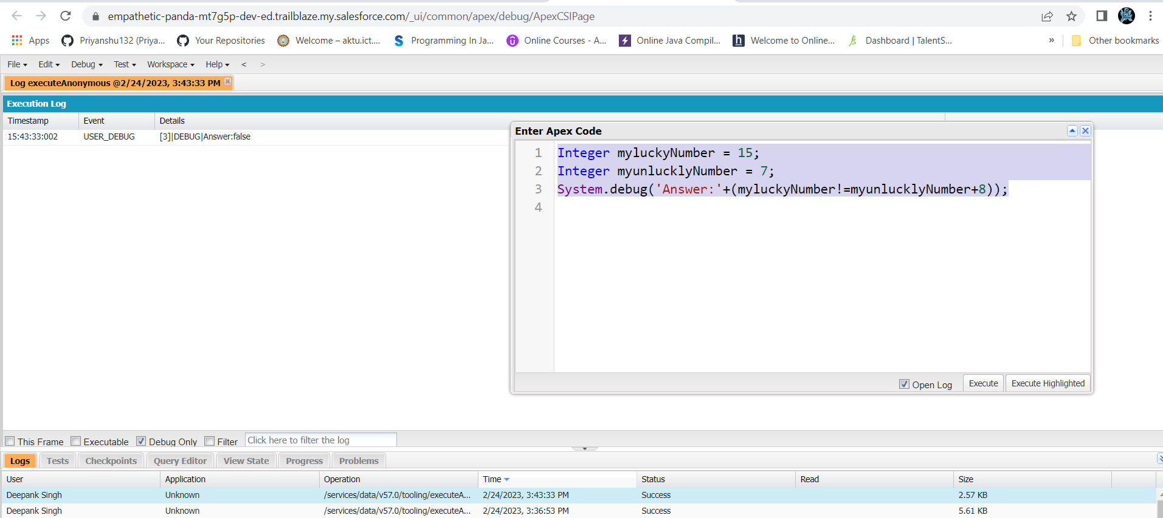

Exercise 4:-

* Code and output:

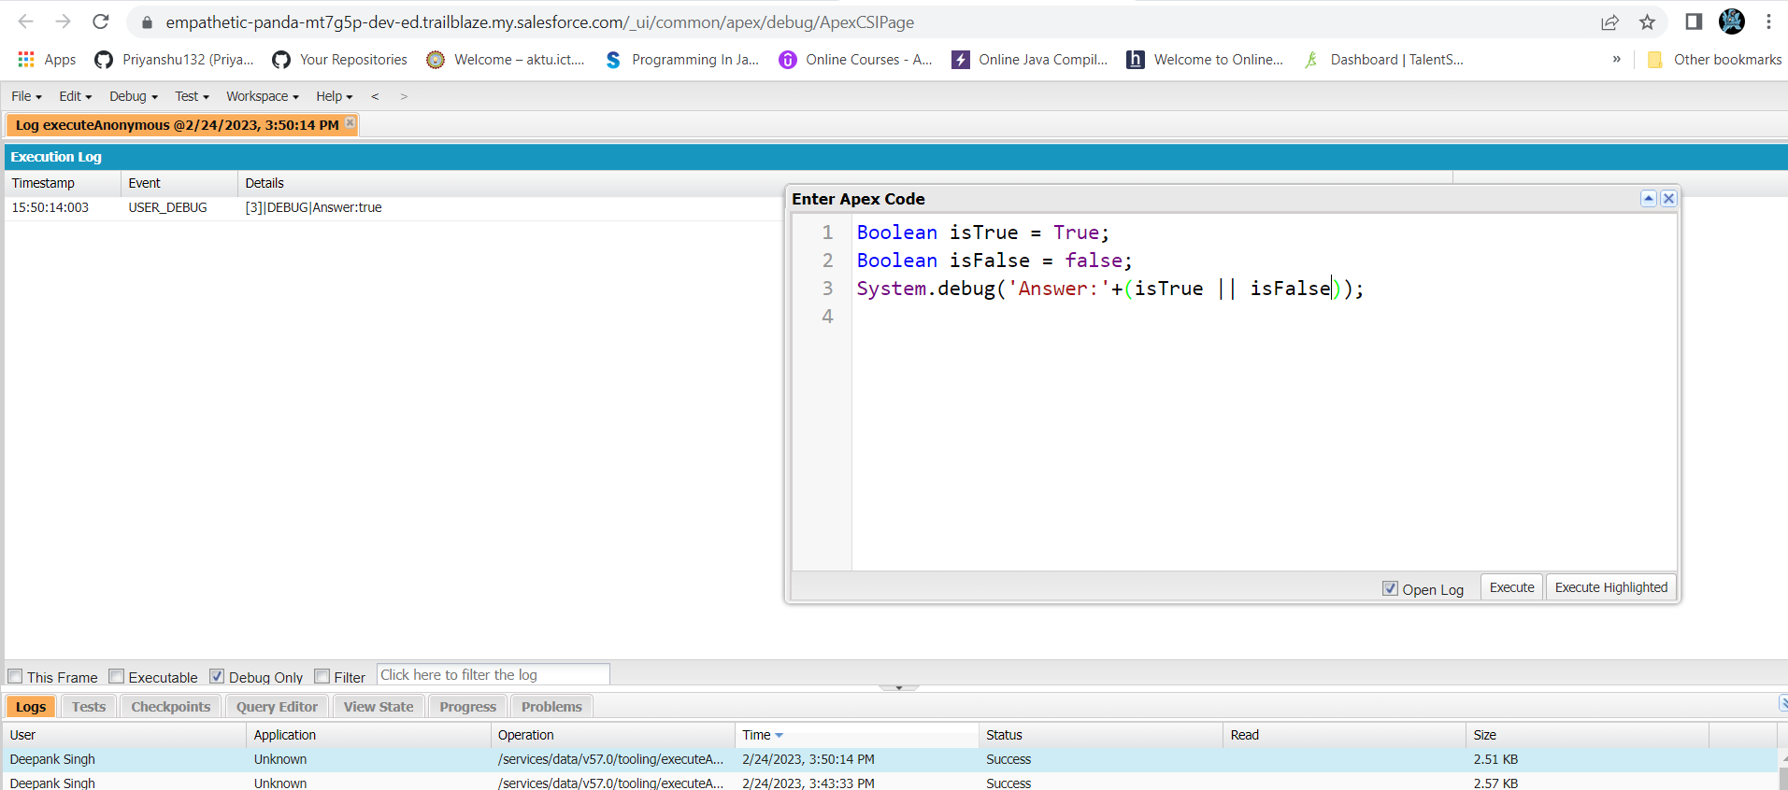

Exercise 5:-

* Code and output:

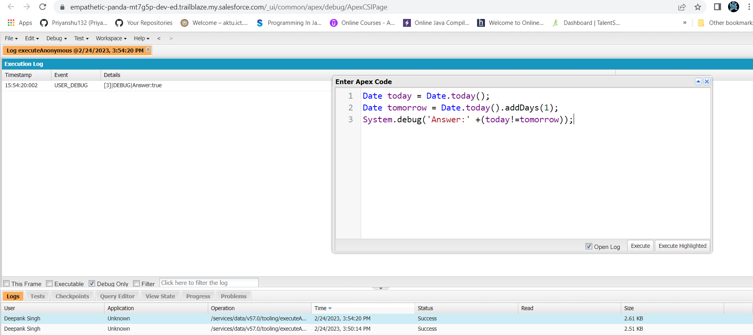

Exercise 6:-

* Code and output:

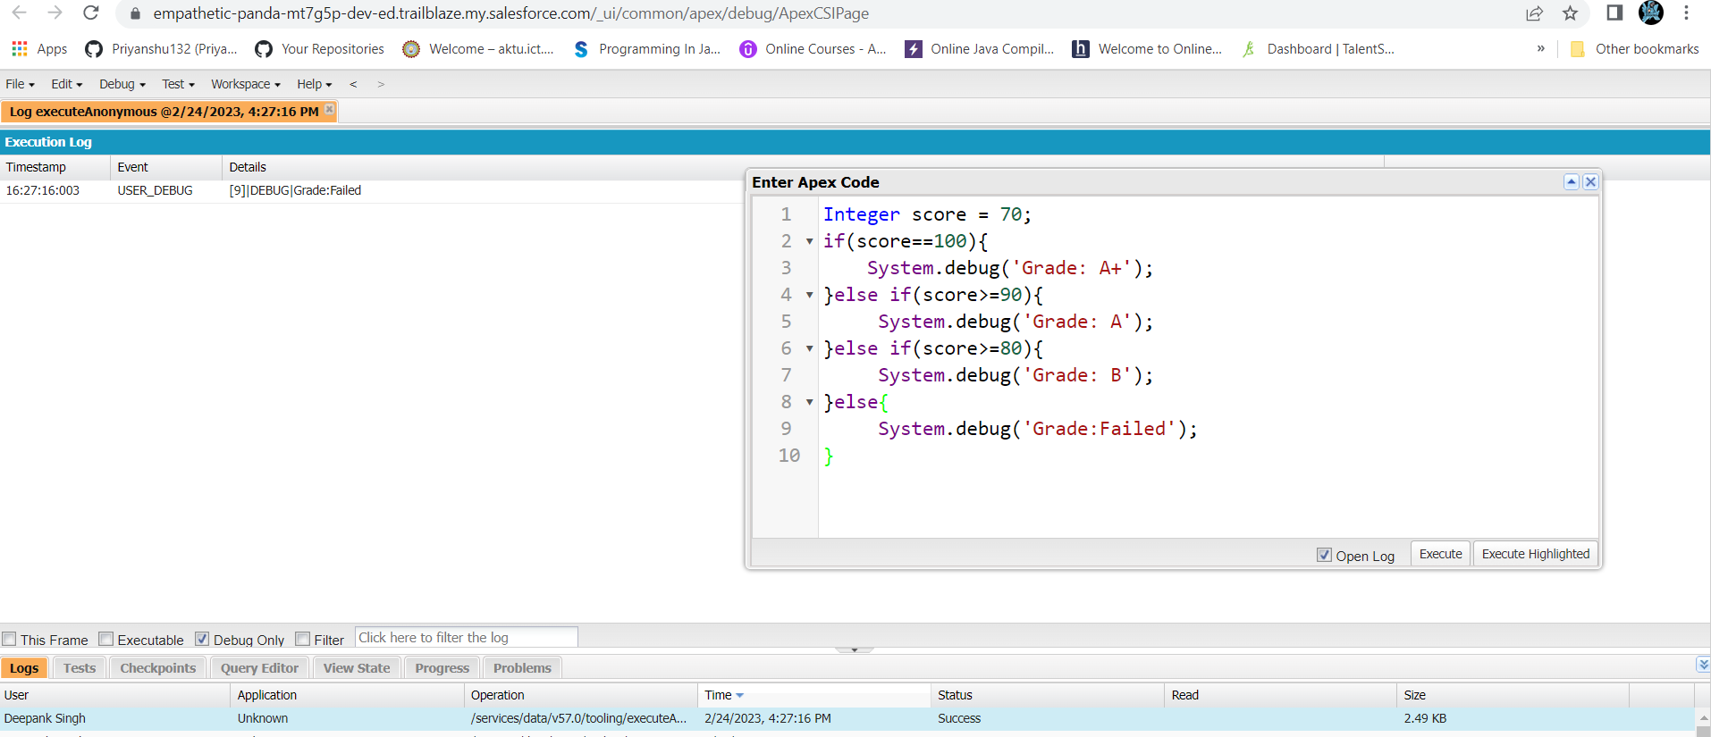

Exercise 7:-

* Code and output:

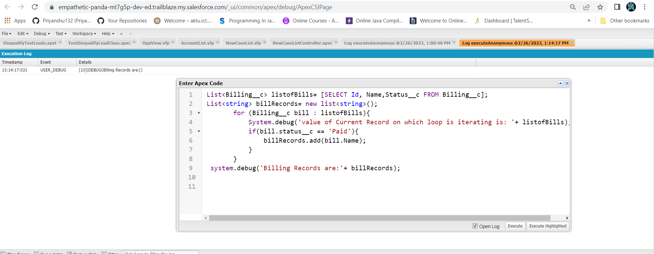

Exercise 8:-

* Code and output:

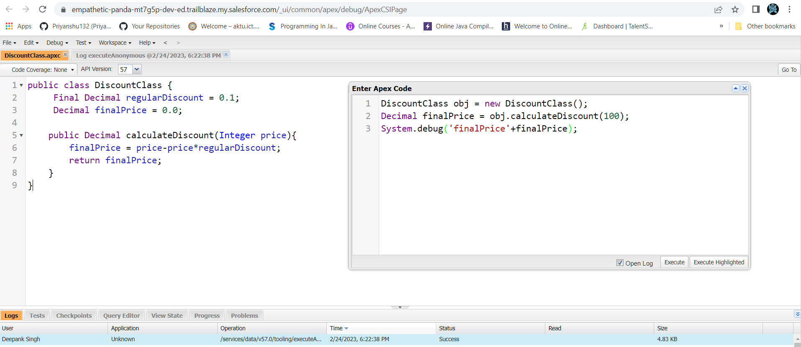

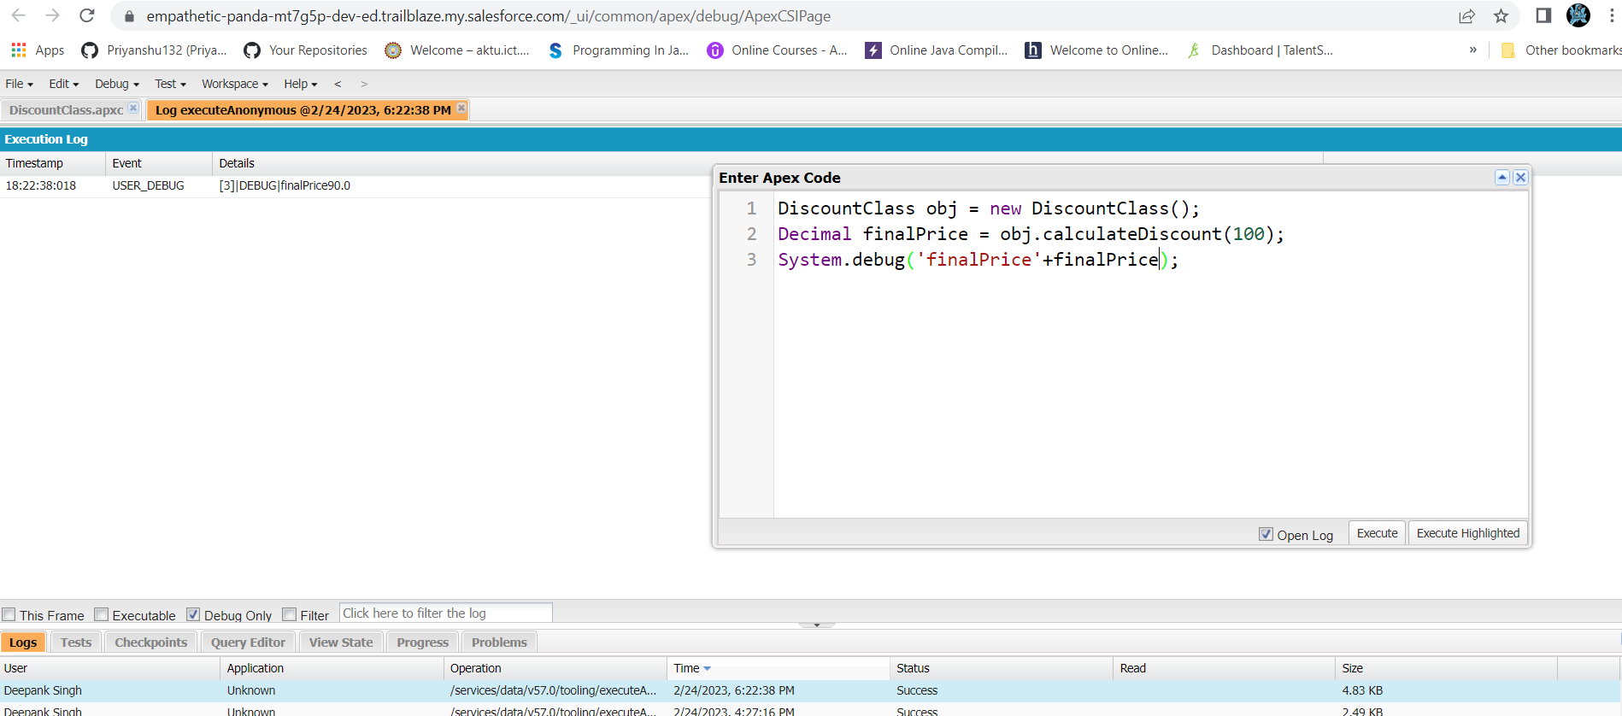

Exercise 9:-

* Code and output:

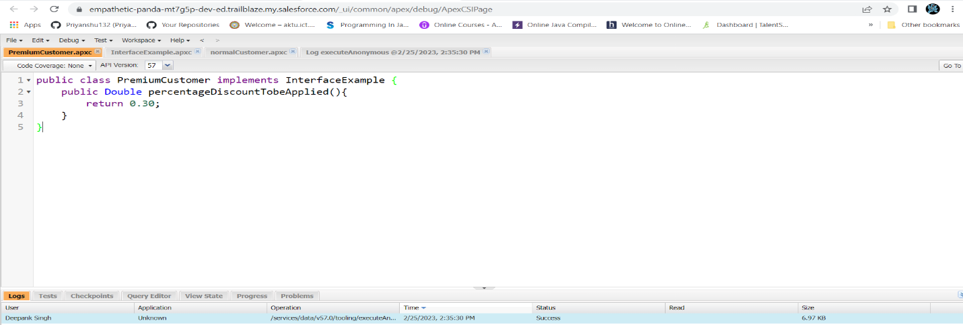

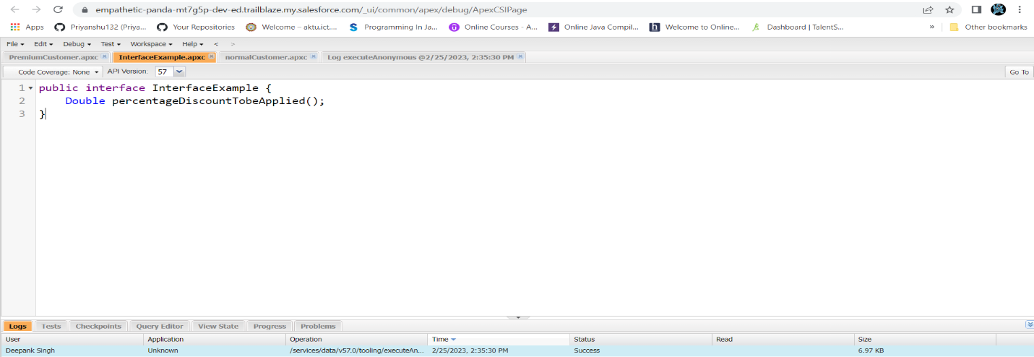

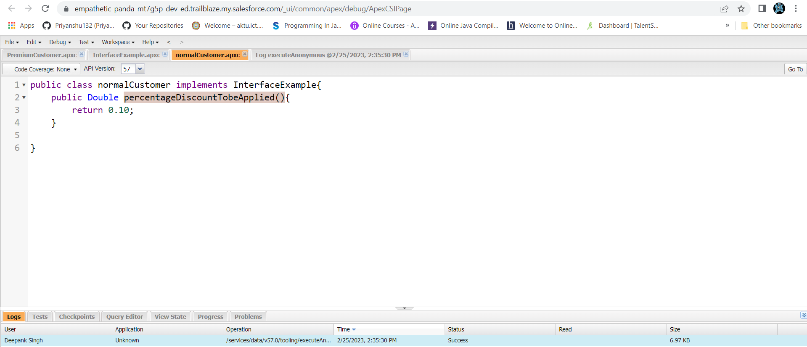

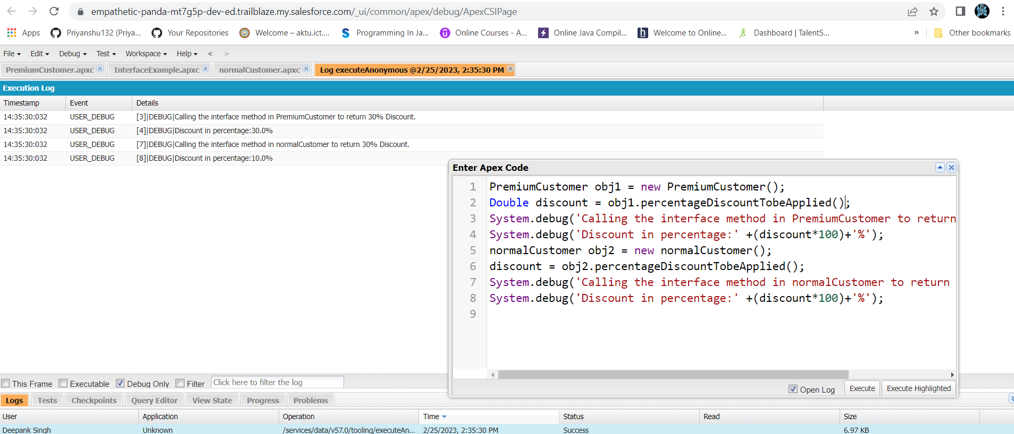

Exercise 10:-

* Code and output:

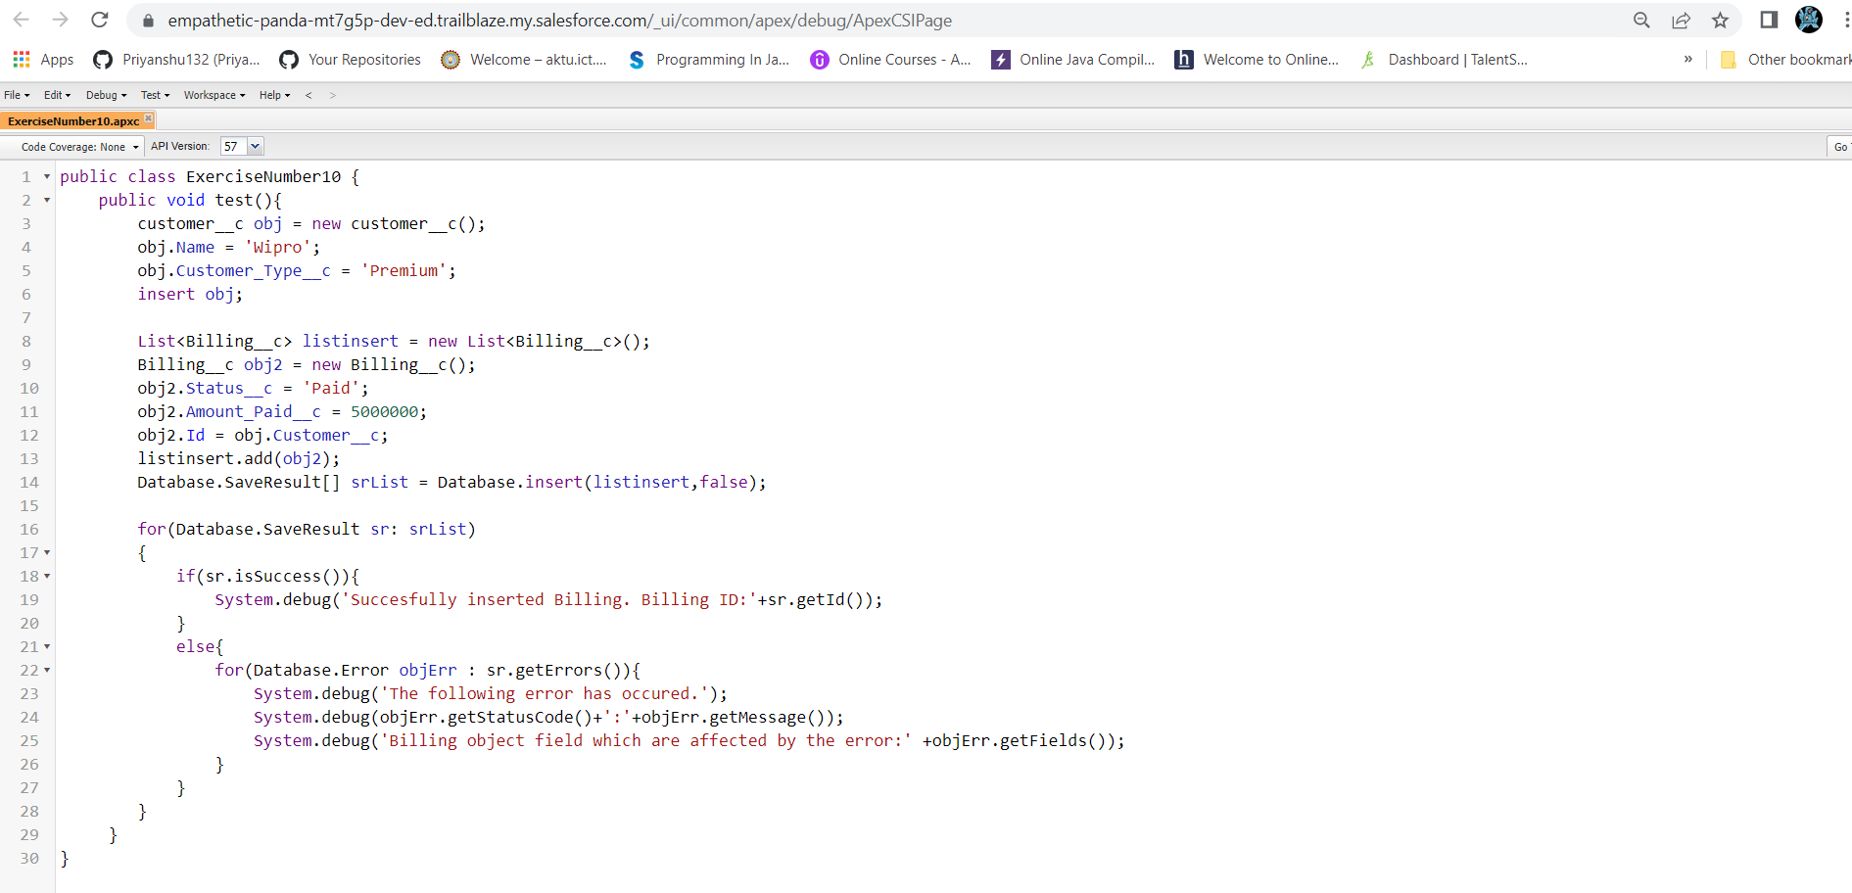

Exercise 11:-

* Code and output:

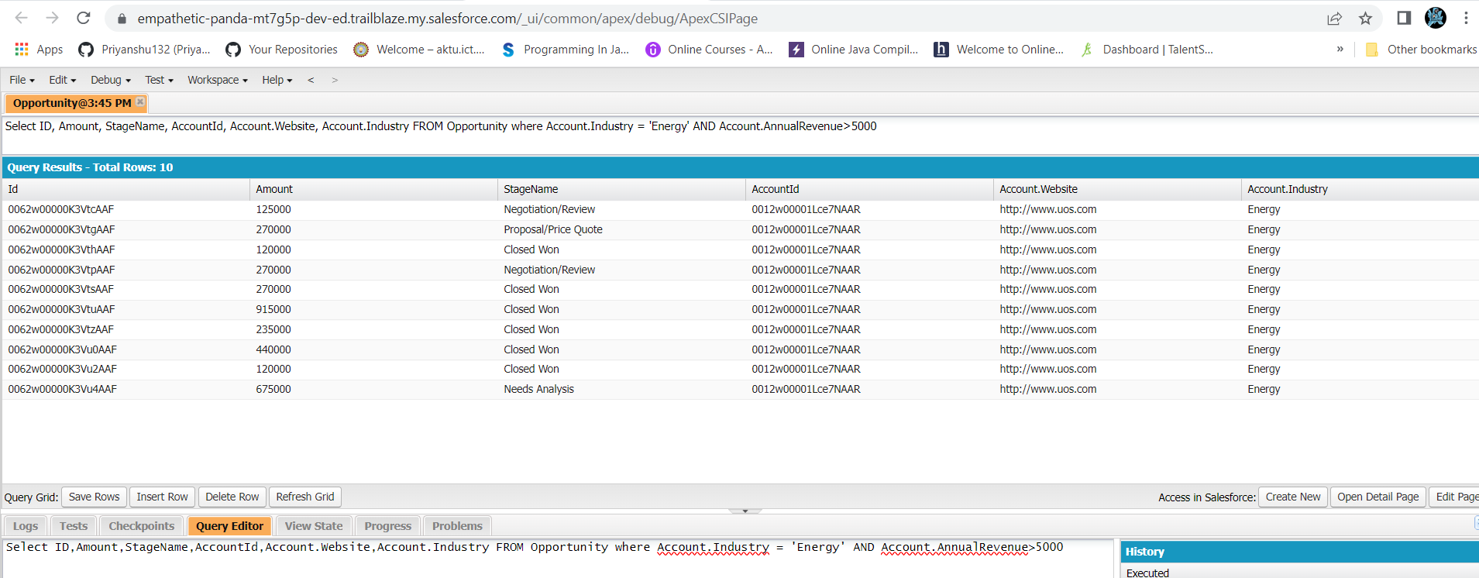

Exercise 12:-

* Code and output:

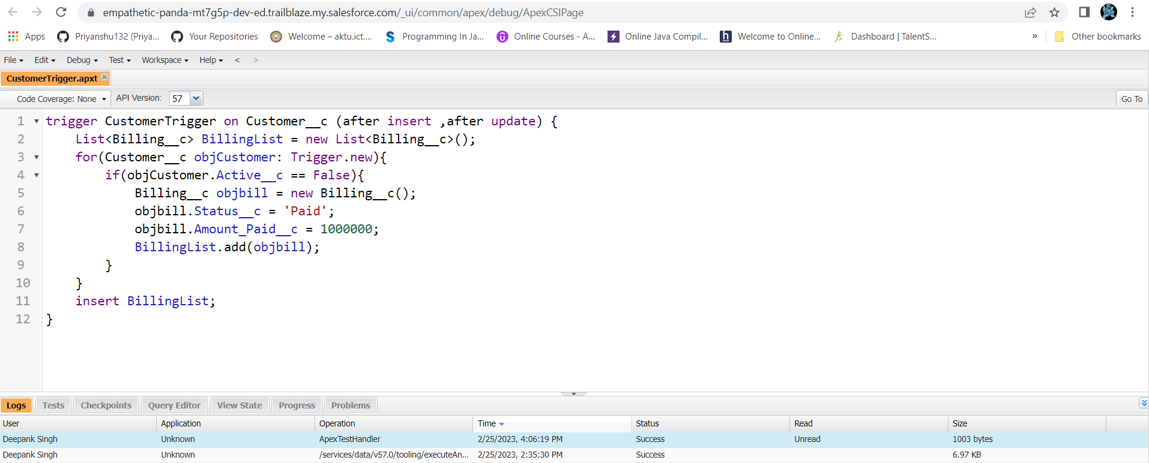

Exercise 13:-

* Code and output:

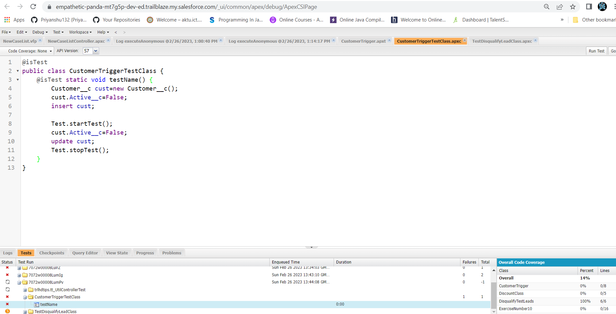

Exercise 14:-

* Code and output:

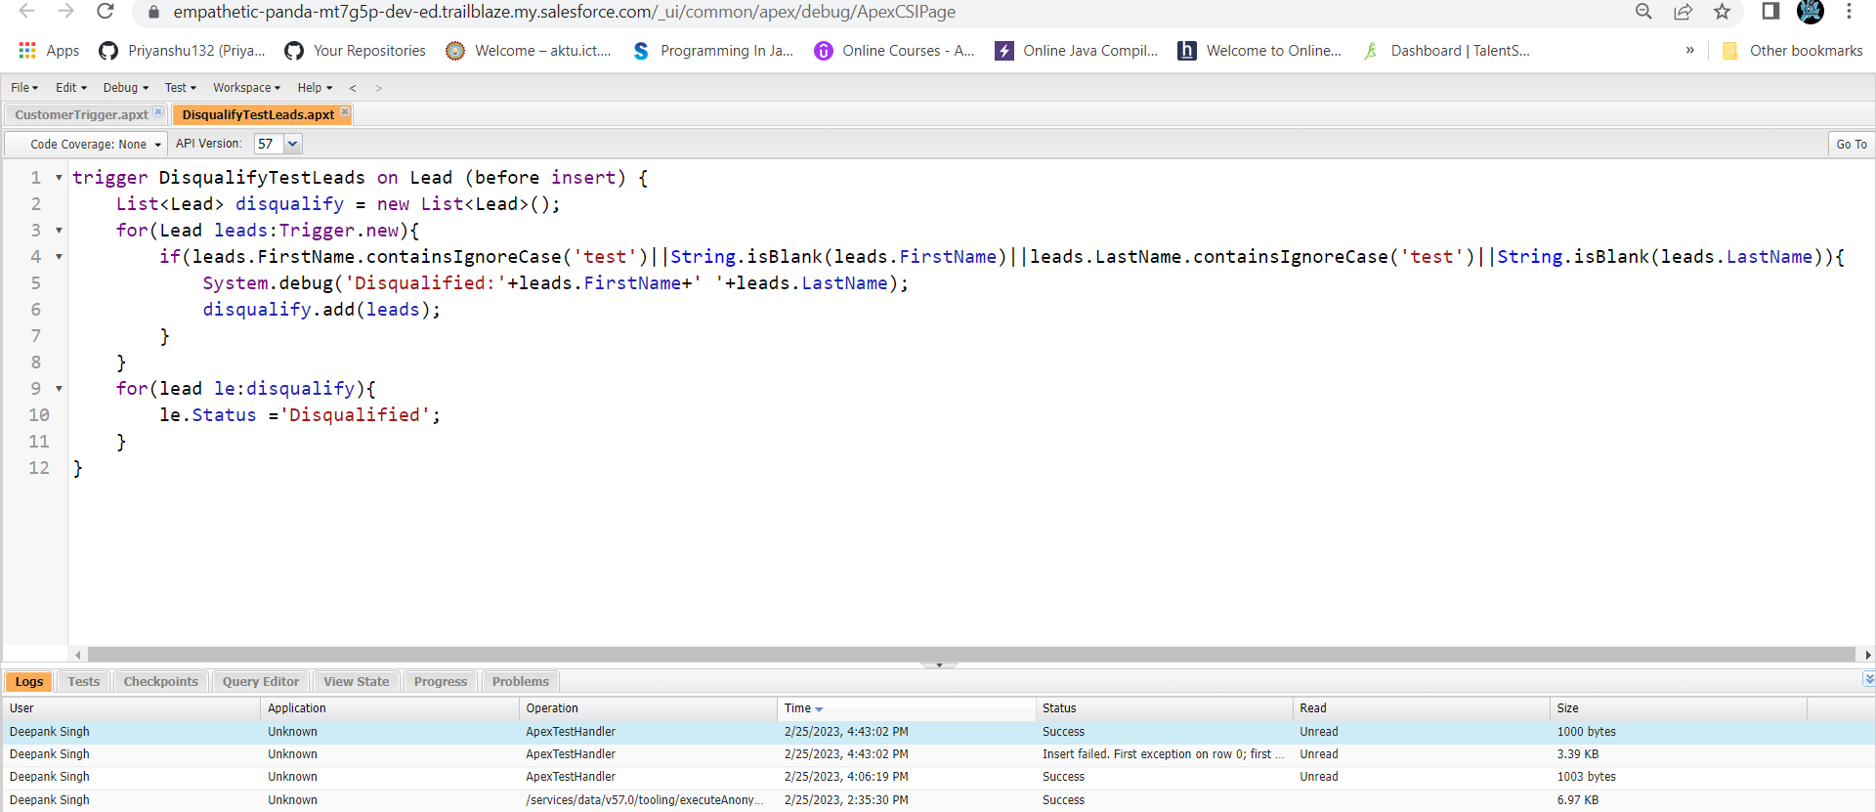

Exercise 15:-

* Code and output:

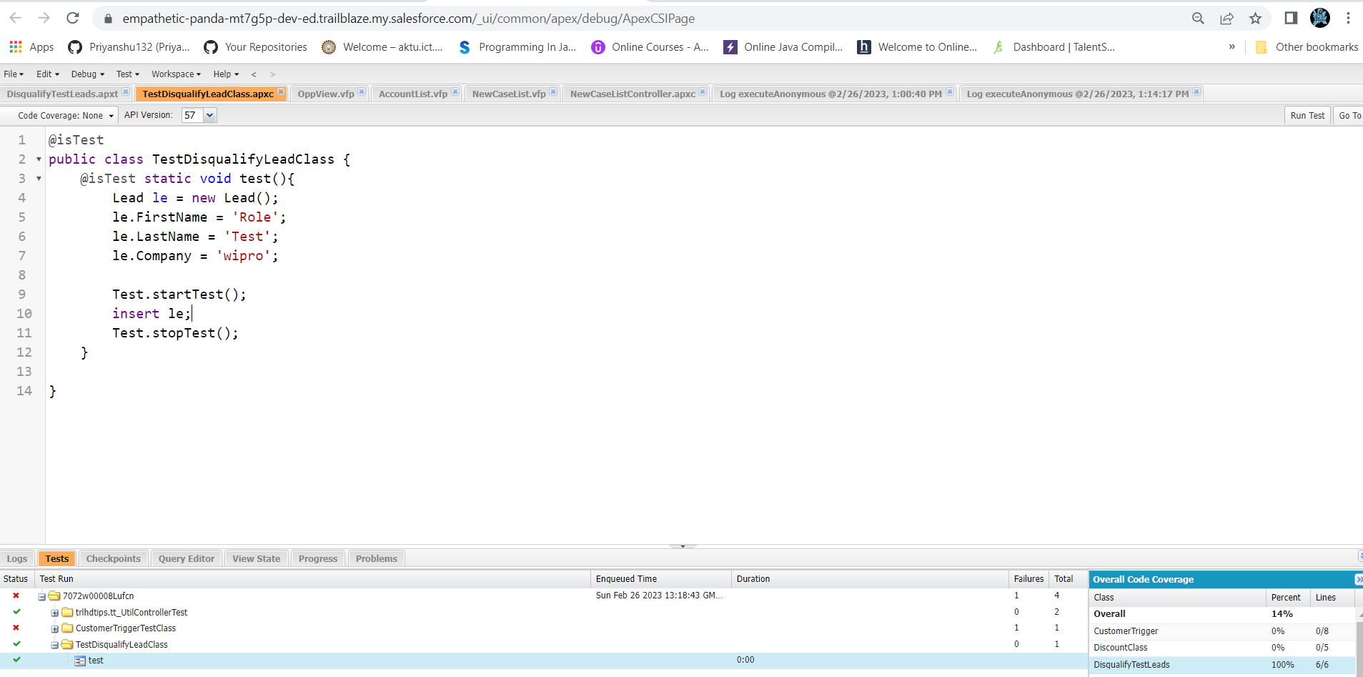

Exercise 16:-

* Code:

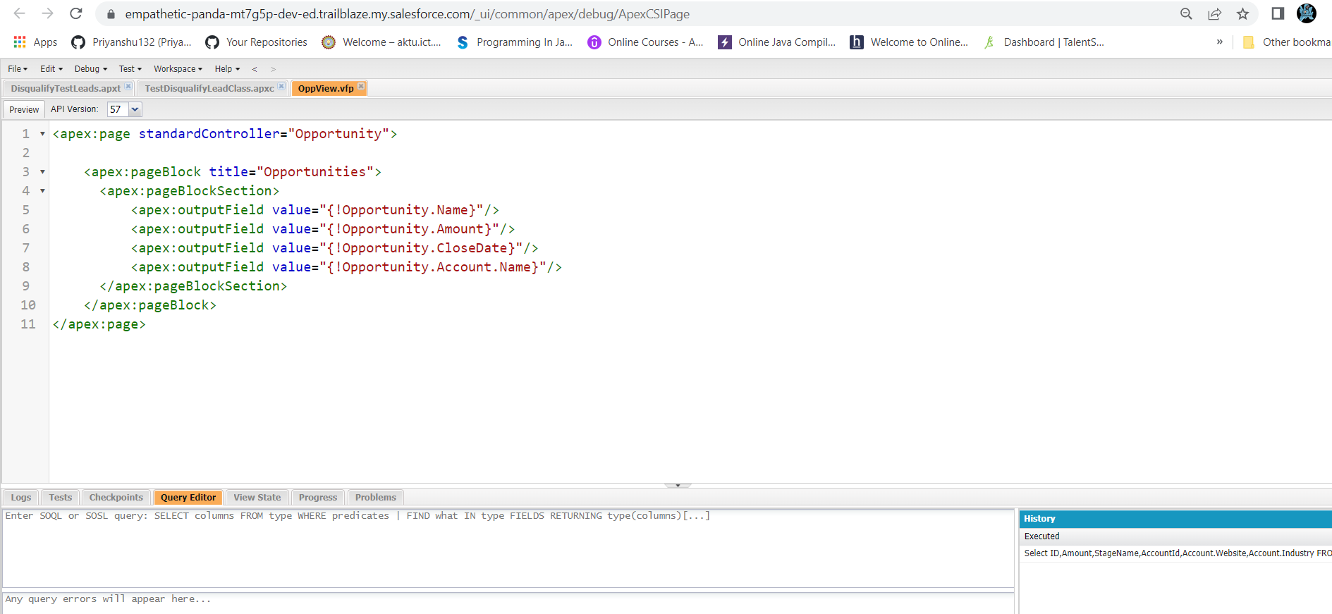

Exercise 17:-

* Code:

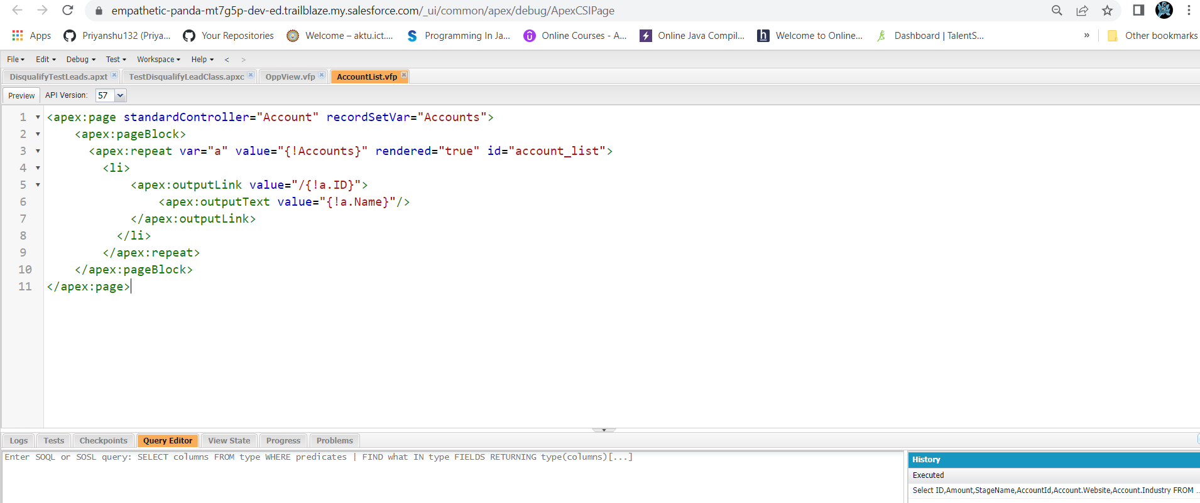

Exercise 18:-

* Code and output:

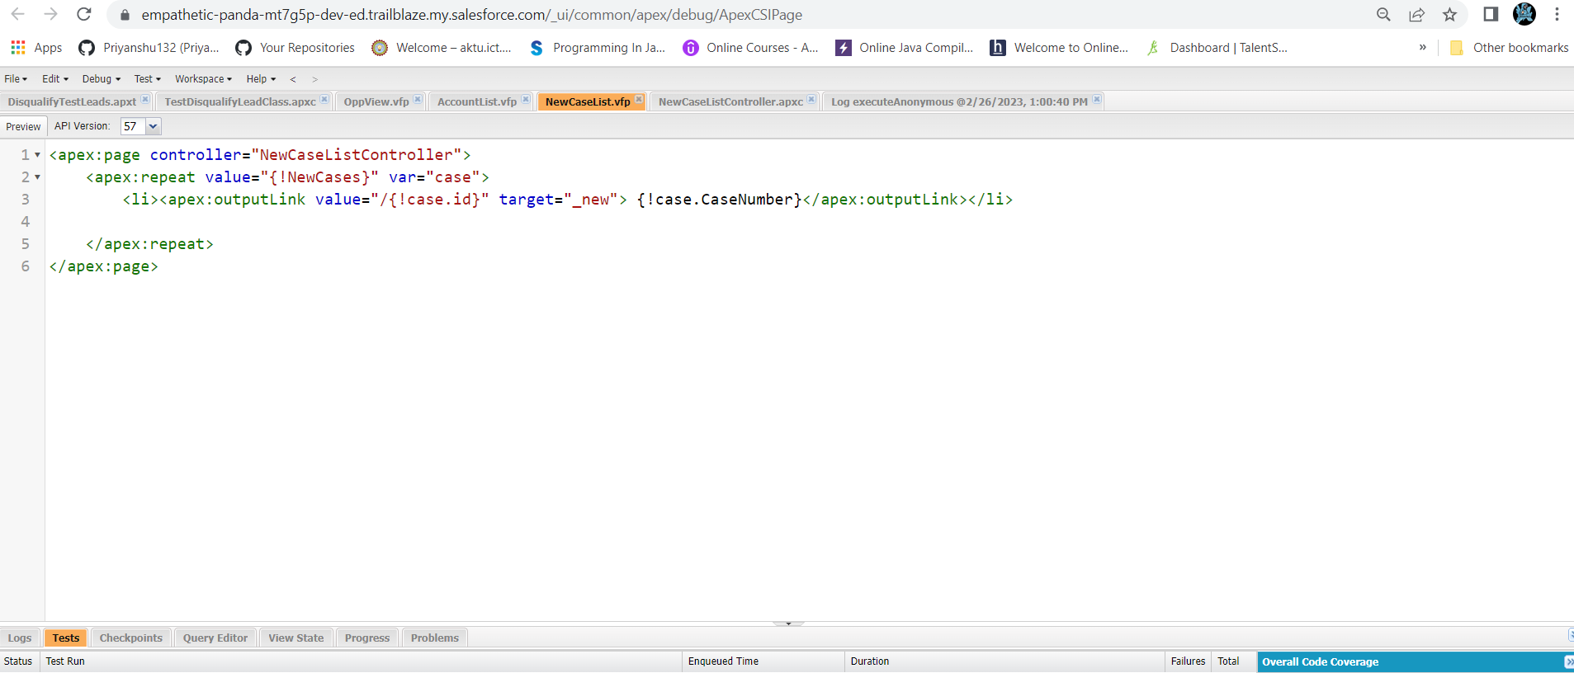

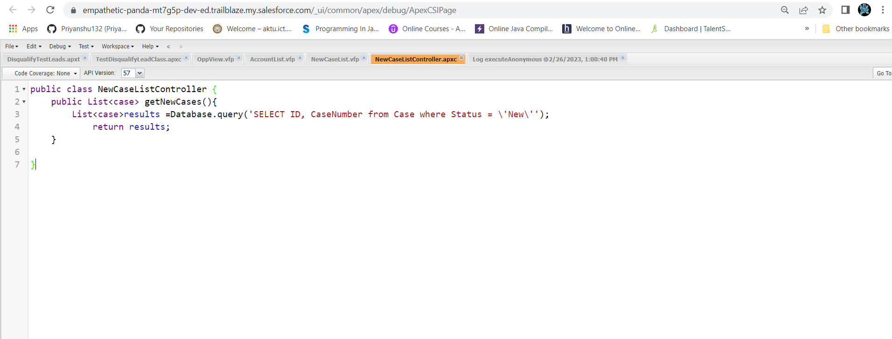

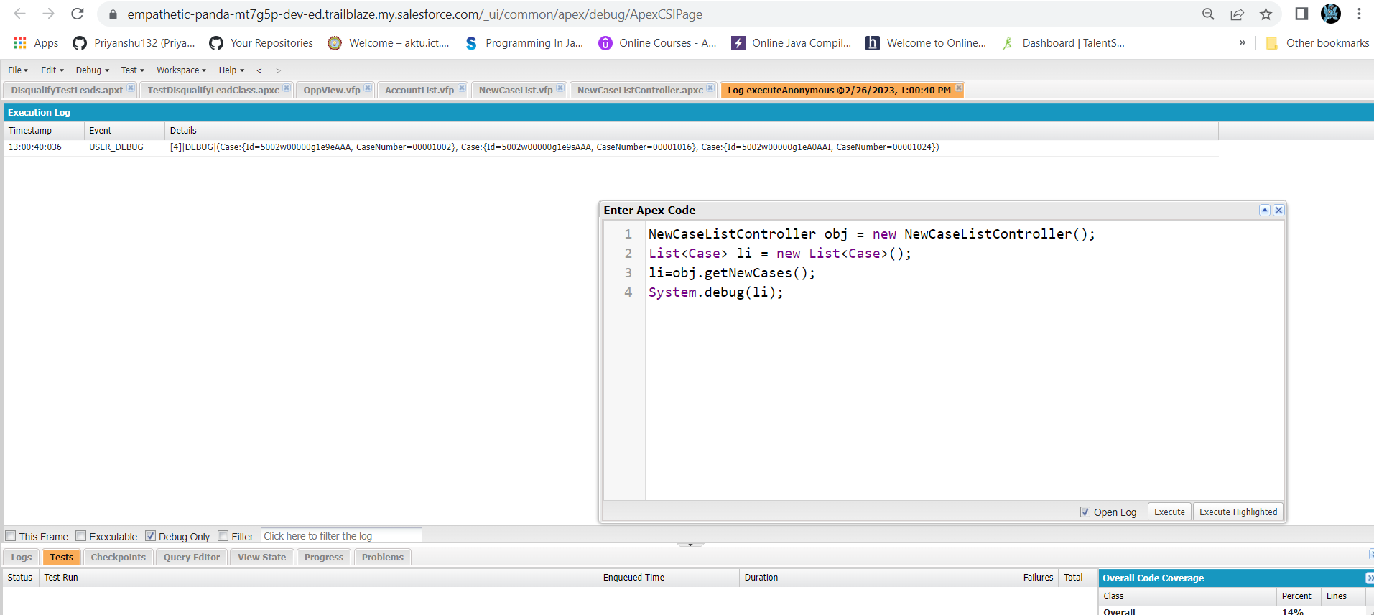

**Future enhancements**

* Whatsapp integration can be done with this app for more connectivity and timely notification.
* Recommendations system can also be integrated with this for recommending various places
* Payment Gateway can be integrated with this app.
* Pre Booked feature can also be added for prebooking .

**References**

1. <https://trailhead.salesforce.com/content/learn/trails/build-a-travel-approval-app>
2. <https://trailhead.salesforce.com/content/learn/projects/build-a-data-model-for-a-travel-approval-app?trail_id=build-a-travel-approval-app>
3. <https://trailhead.salesforce.com/content/learn/projects/customize-the-user-interface-for-a-travel-approval-app?trail_id=build-a-travel-approval-app>
4. <https://trailhead.salesforce.com/content/learn/projects/add-business-logic-to-a-travel-approval-app?trail_id=build-a-travel-approval-app>
5. <https://trailhead.salesforce.com/content/learn/projects/add-reports-and-dashboards-to-a-travel-approval-app?trail_id=build-a-travel-approval-app>
6. <https://trailhead.salesforce.com/content/learn/modules/apex_triggers>